

## 

Table of Contents

**Introduction:** 4

**Network Topology:** 6

**Show IP interface brief:** 8

16

**Show IP Route Command:** 17

25

**Show Running Configuration:** 26

**Result for some examples (i.e. NAT, ACL, PS, Redistribution):** 43

**NAT:** 43

**ACL:** 45

**Port Security:** 46

**Redistribution:** 47

50

**PCs Screenshot:** 51

**Conclusion:** 53



## **Introduction:**

The Hospital Management System (HMS) in Cisco Packet Tracer is an intricate simulation designed to illustrate how modern networking technologies can be applied to manage a hospital's communication infrastructure effectively. This project encompasses a variety of network components, including routers, switches, PCs, servers, and firewalls, all working together to provide a robust and secure network environment. The HMS network employs both public and private IP addressing to facilitate internal and external communication. Key features of the project include the implementation of Network Address Translation (NAT) and Port Address Translation (PAT) to manage IP address space efficiently and securely connect to the internet. Variable Length Subnet Masking (VLSM) is utilized to optimize IP address allocation, ensuring that different departments within the hospital can operate efficiently without wasting valuable IP resources. The network design adheres to a hierarchical model, promoting scalability and ease of management through the use of core, distribution, and access layers. Security is a paramount concern in the HMS, addressed through the configuration of firewalls and access control lists (ACLs) to protect sensitive medical data and ensure compliance with healthcare regulations.

Overall, the HMS in Cisco Packet Tracer is a comprehensive project that demonstrates the integration of essential networking components and advanced configurations to create a secure, efficient, and scalable network infrastructure tailored for a hospital setting. This simulation not only highlights the practical application of networking principles but also underscores the importance of security and efficient resource management in a healthcare environment.

## 

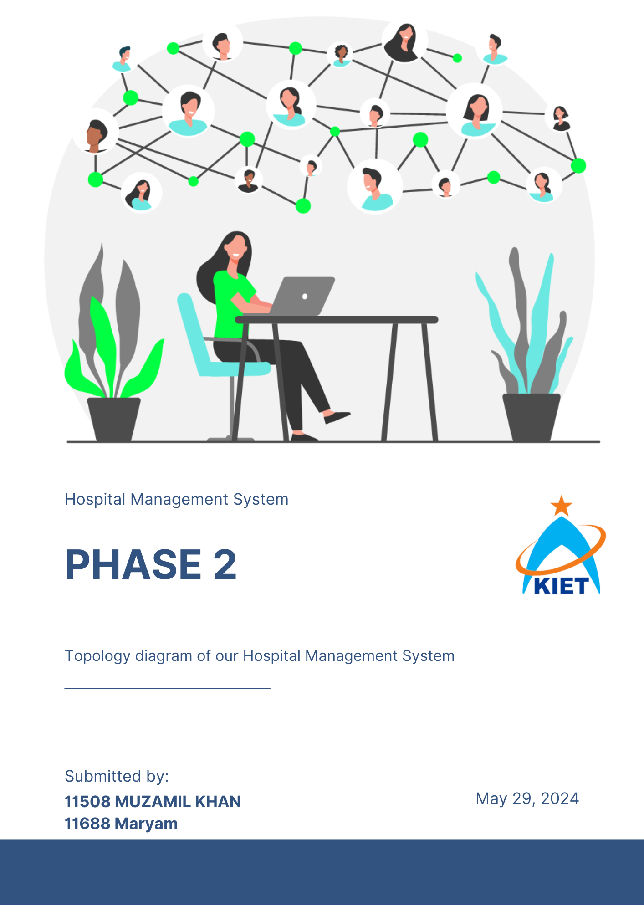

## **Network Topology:**

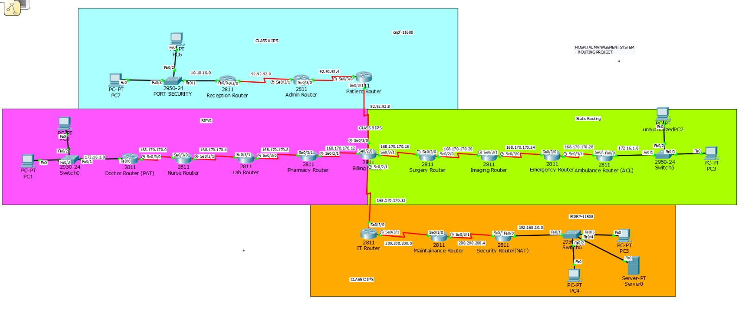

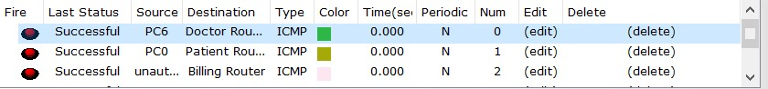

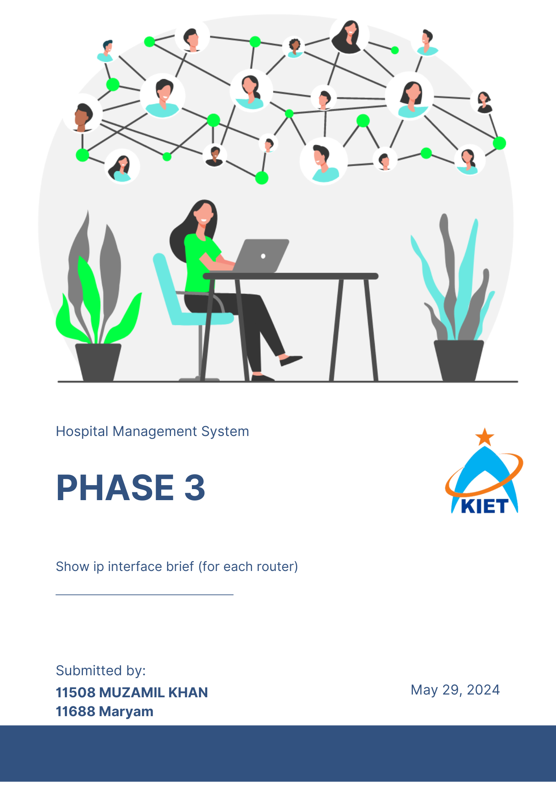

## **Show IP interface brief:**

*Reception Router:*

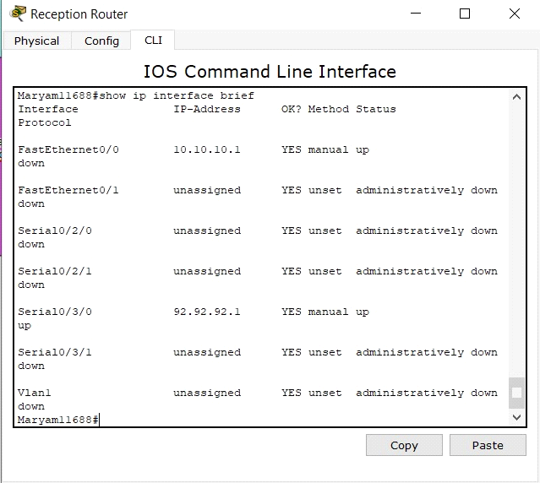

*Admin Router:*

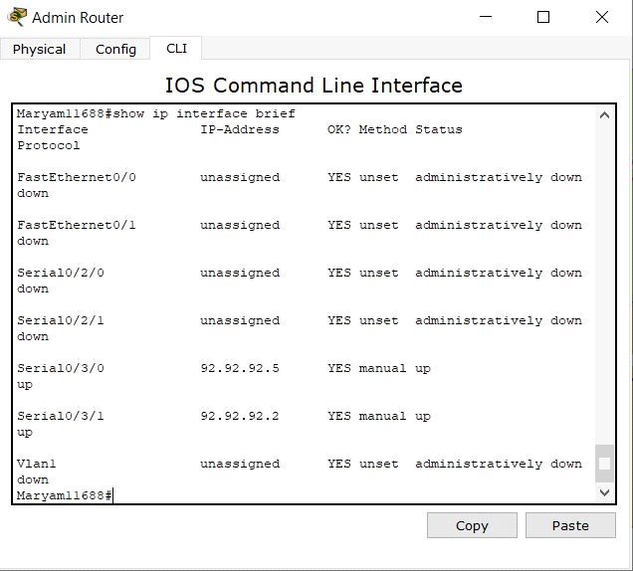

*Patient Router:*

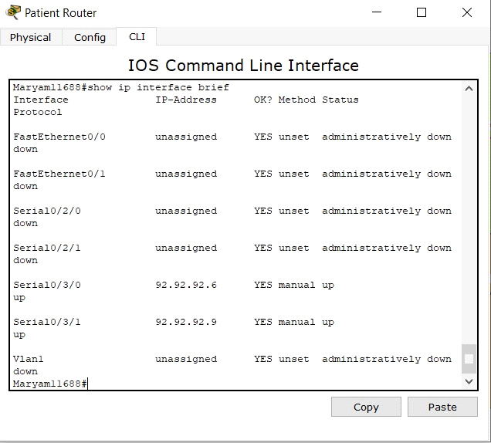

*Doctor Router:*

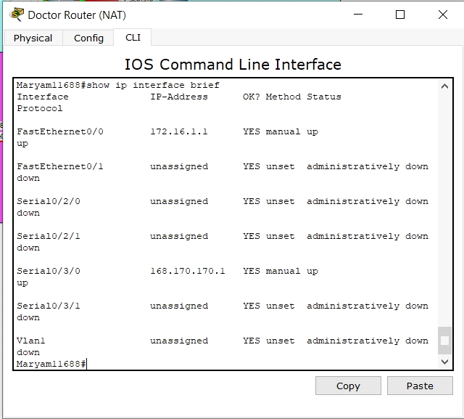

*Nurse Router:*

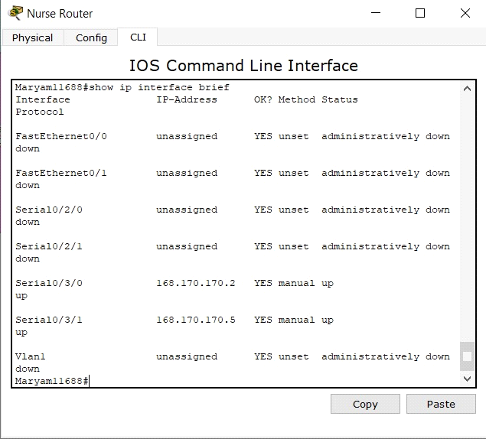

*Lab Router:*

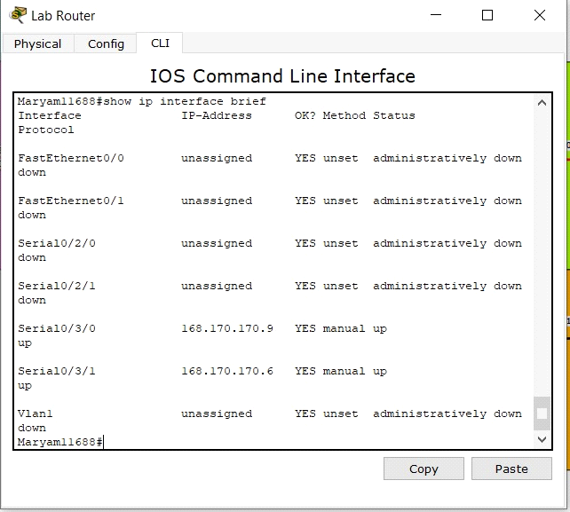

*Pharmacy Router:*

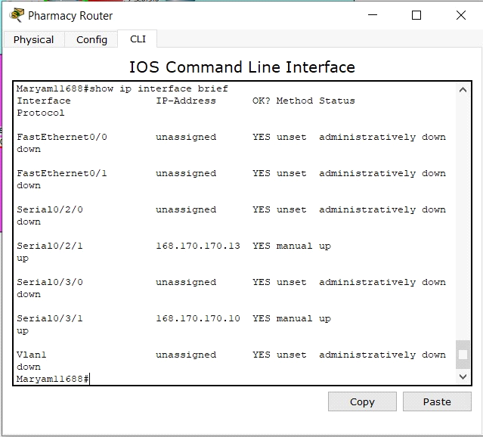

*Billing Router:*

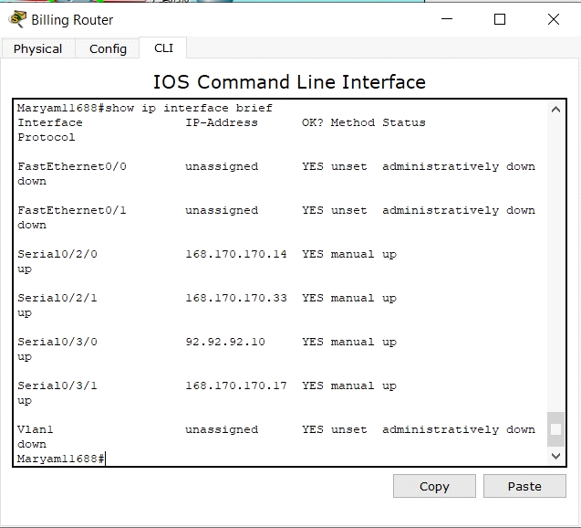

*Surgery Router:*

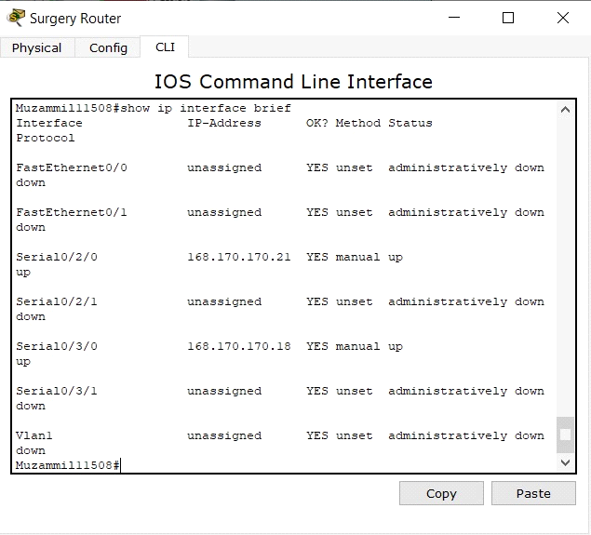

*Imagin Router:*

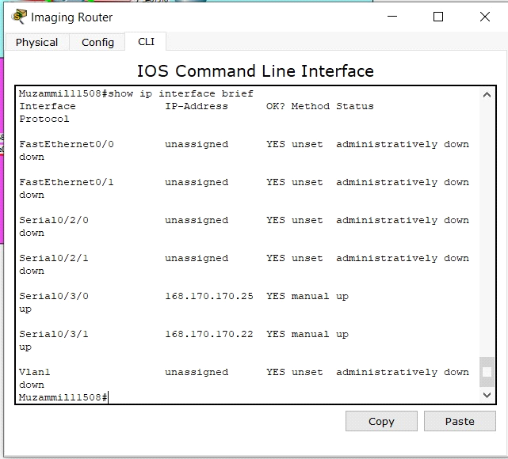

*Emergency Router:*

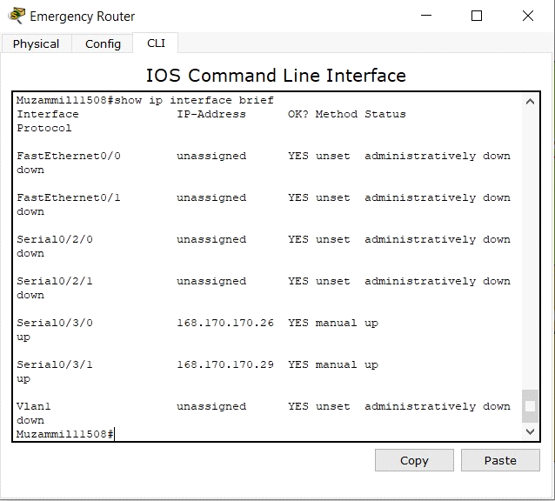

*IT Router:*

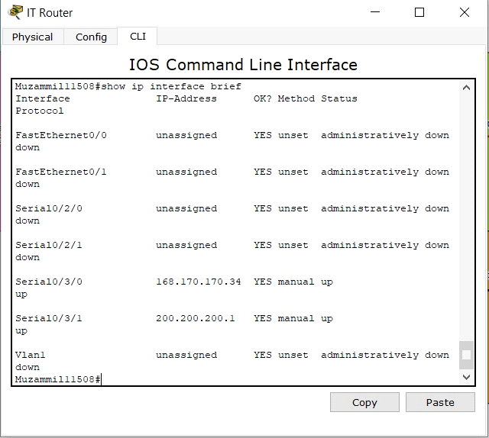

*Ambulance Router:*

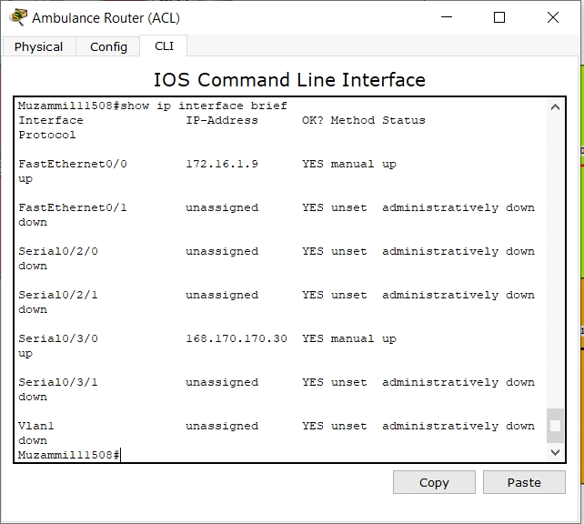

*Maintenance Router:*

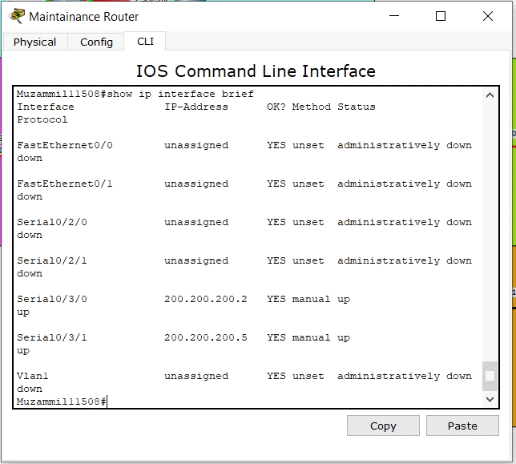

*Security Router*

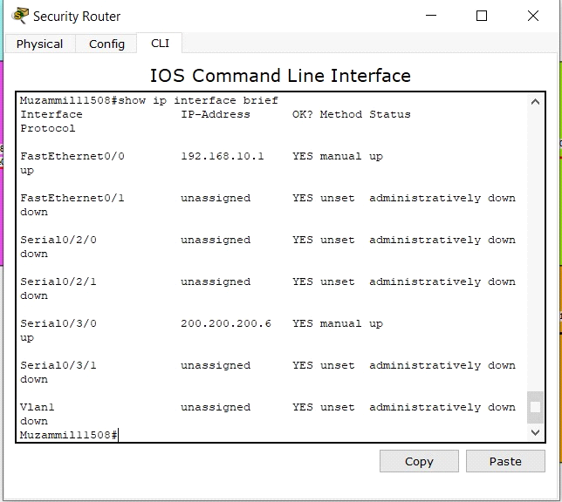

## 

## **Show IP Route Command:**

*Patent Router:*

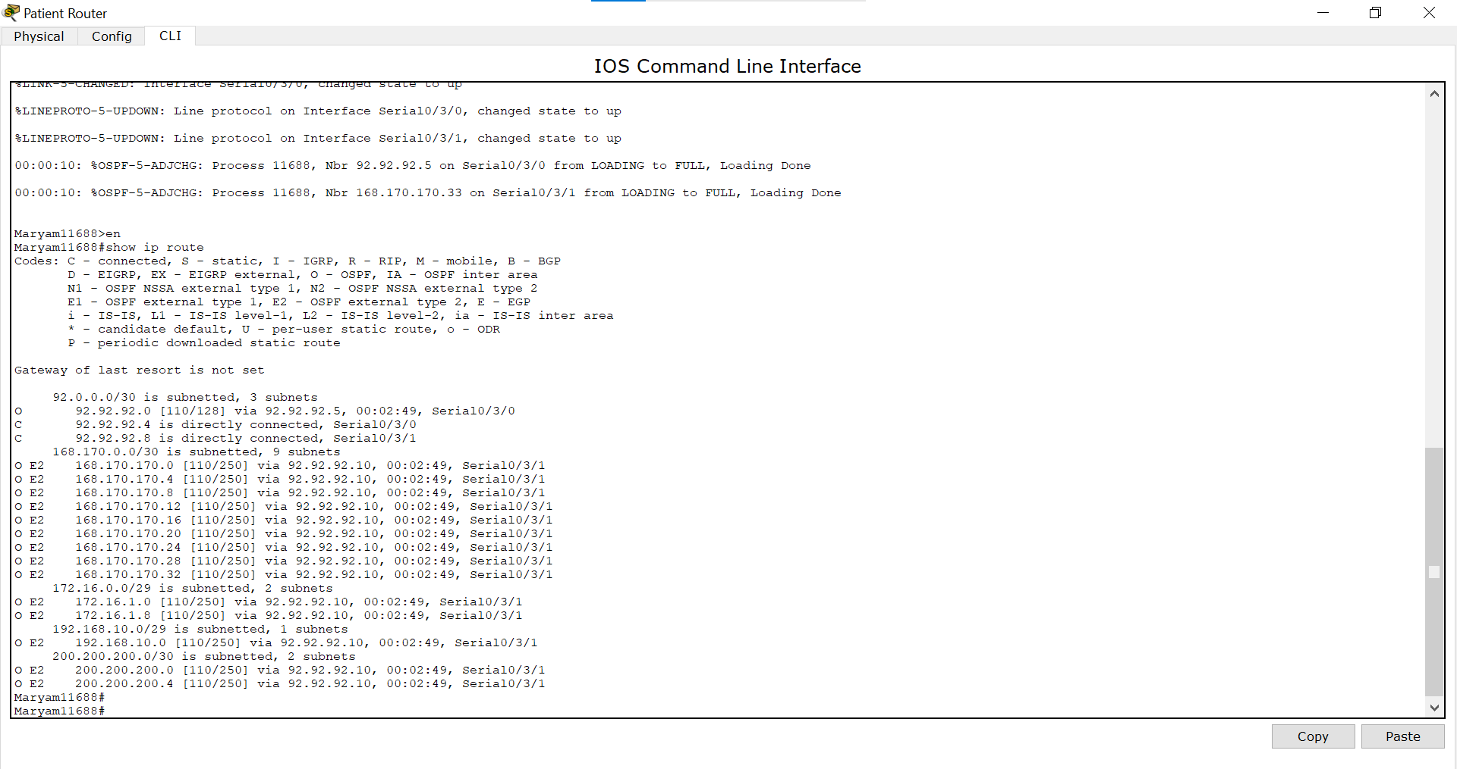

*Admin Router:*

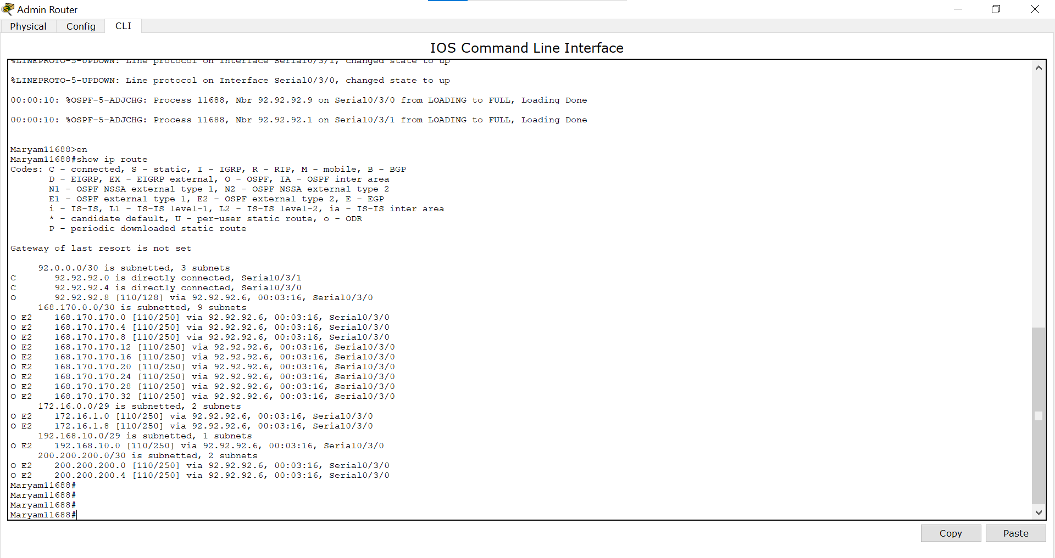

*Reception Router:*

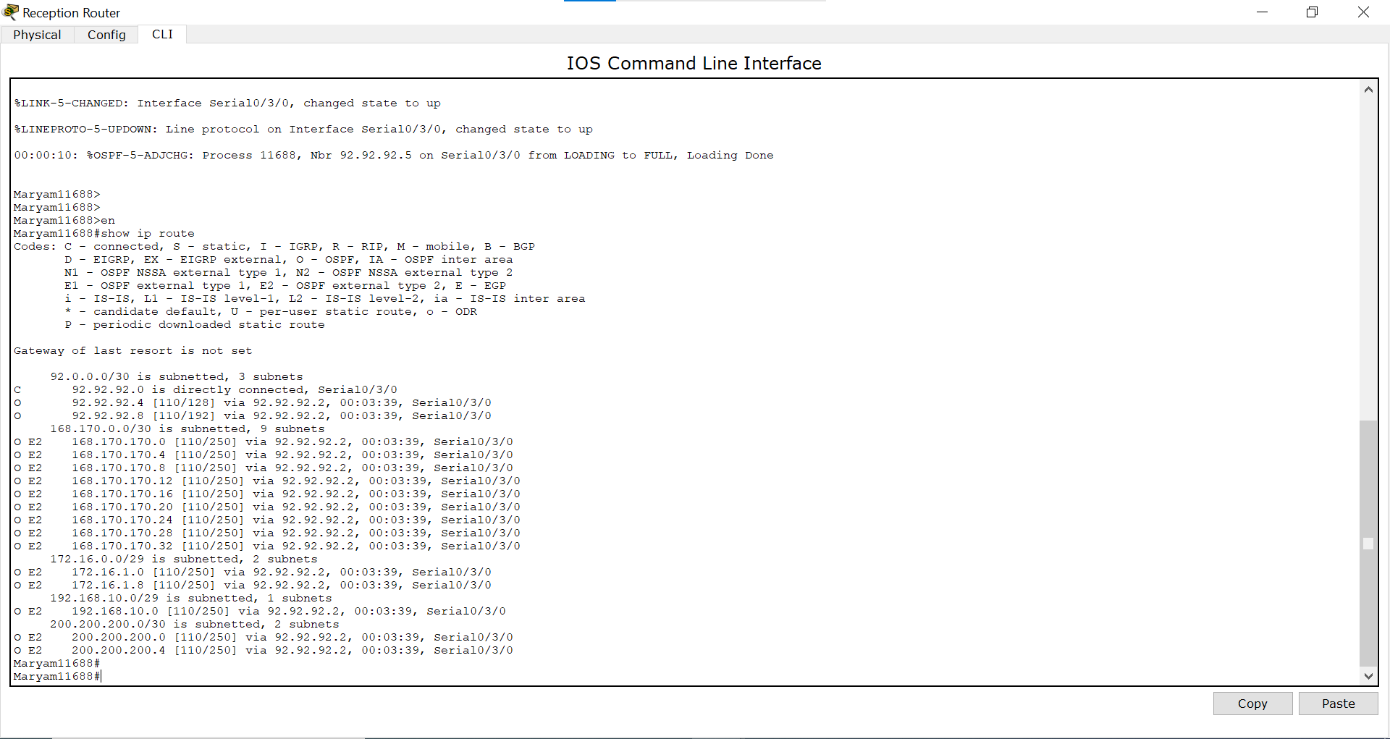

*Ambulance Router:*

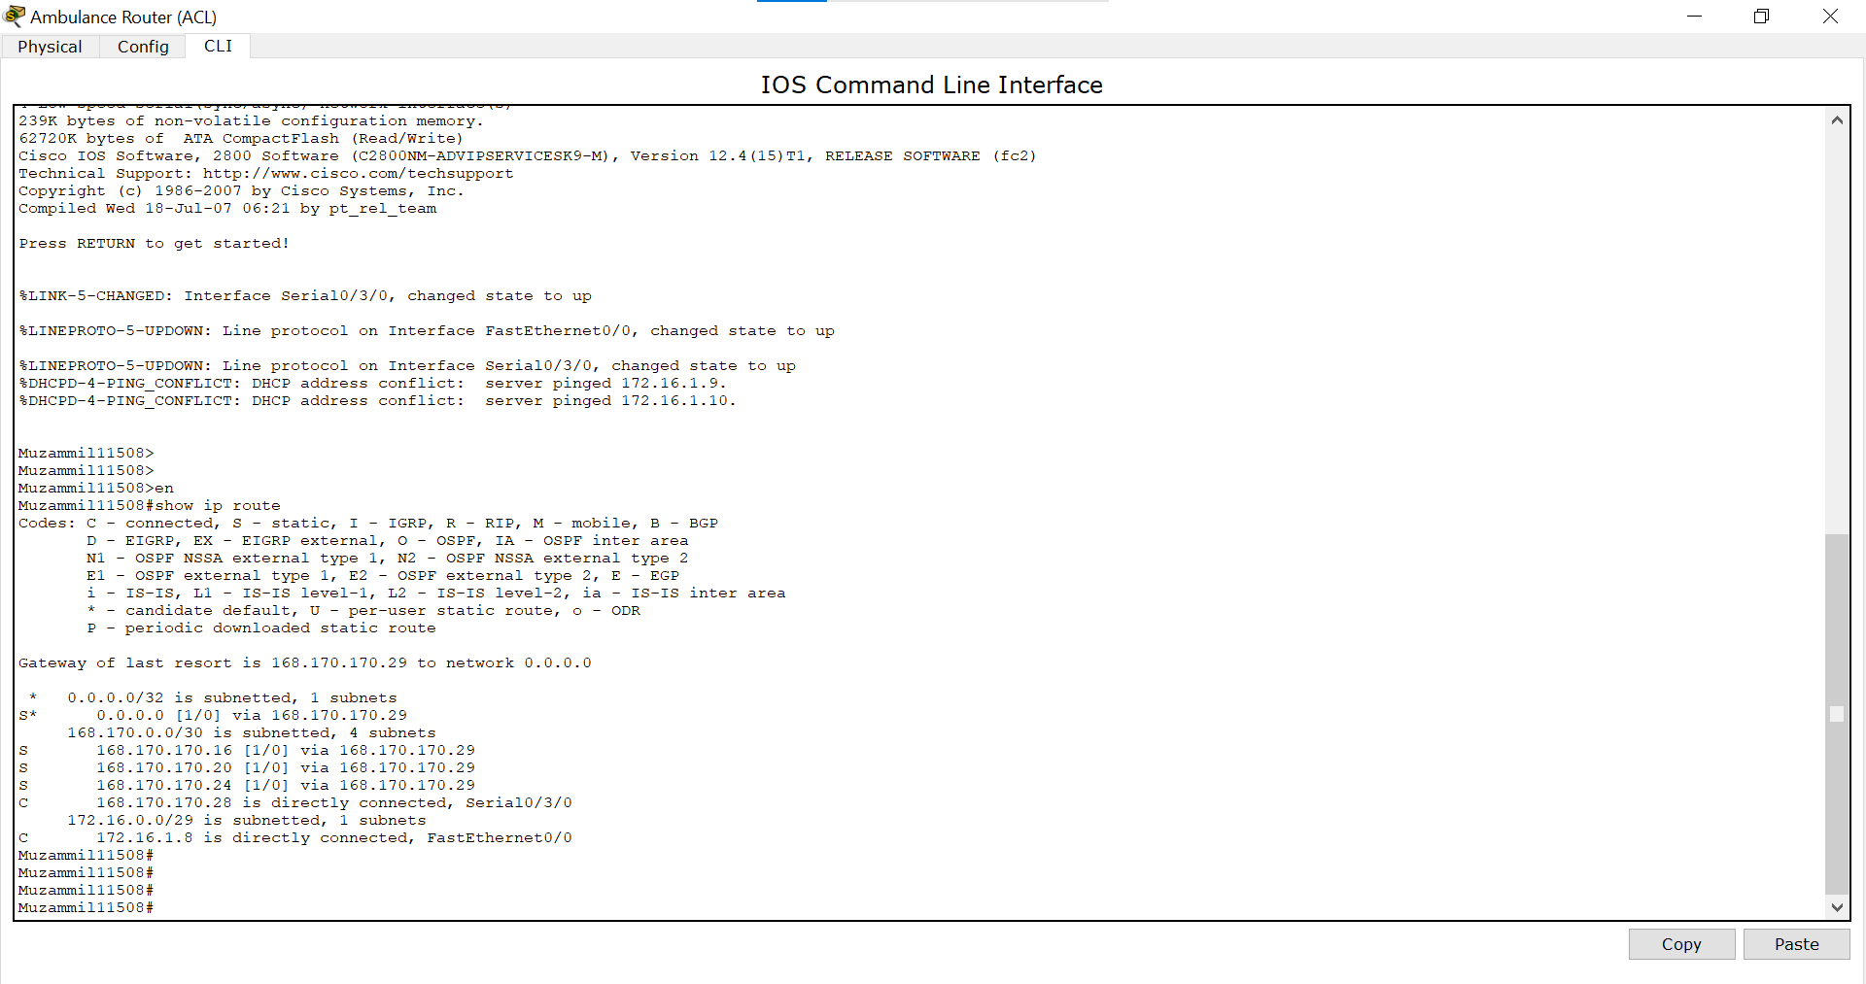

*Emergency Router:*

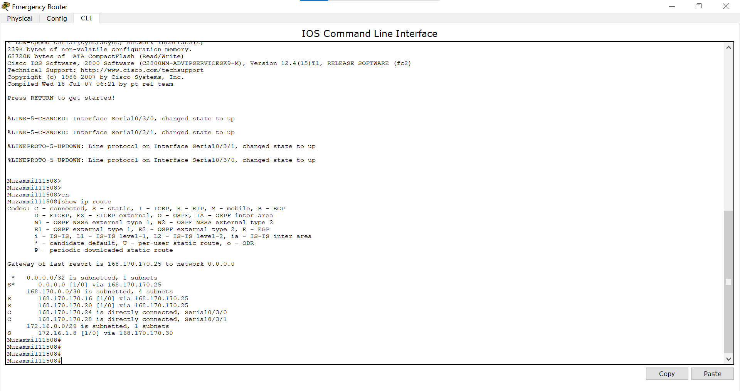

*Imaging Router:*

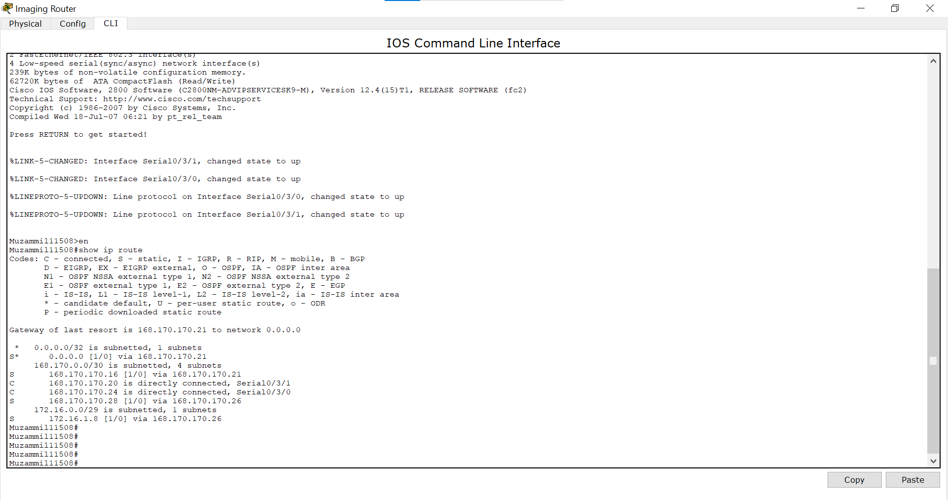

*Surgery Router:*

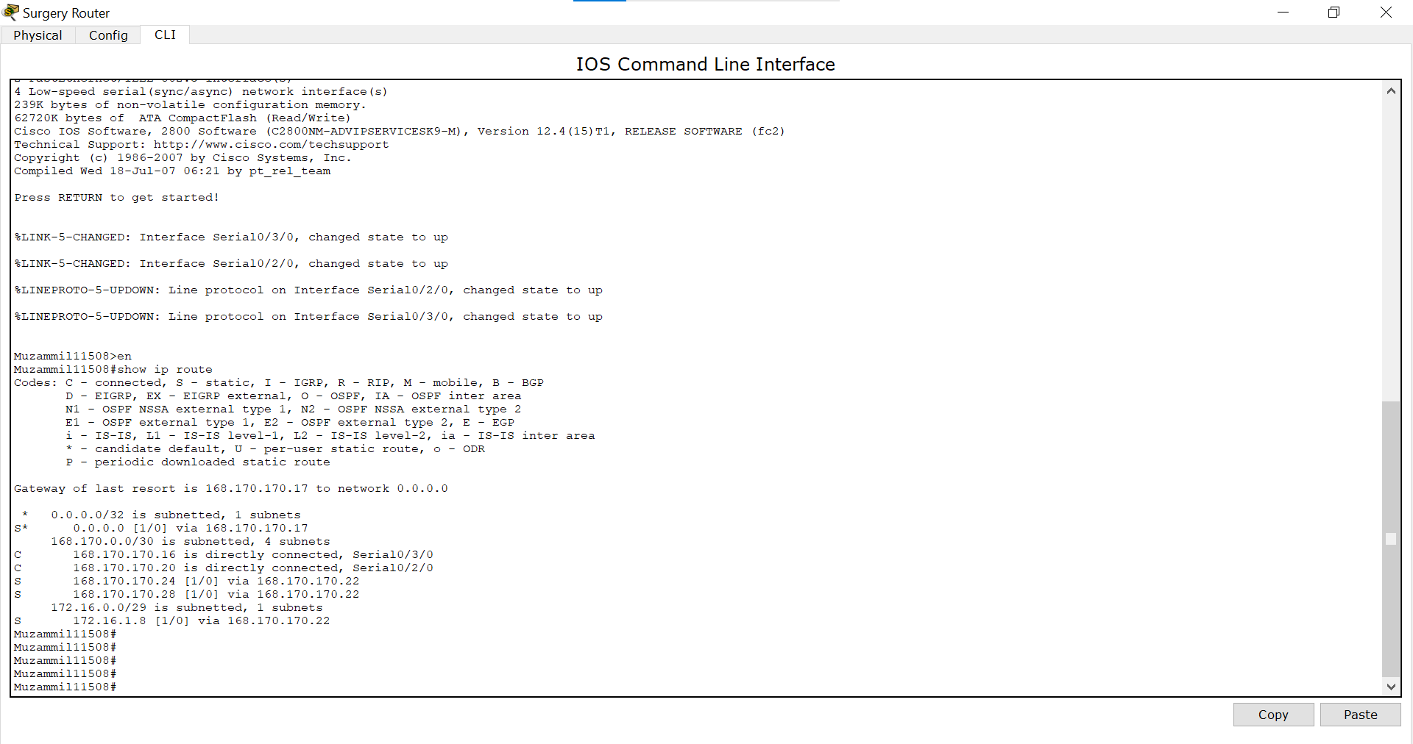

*Billing Router:*

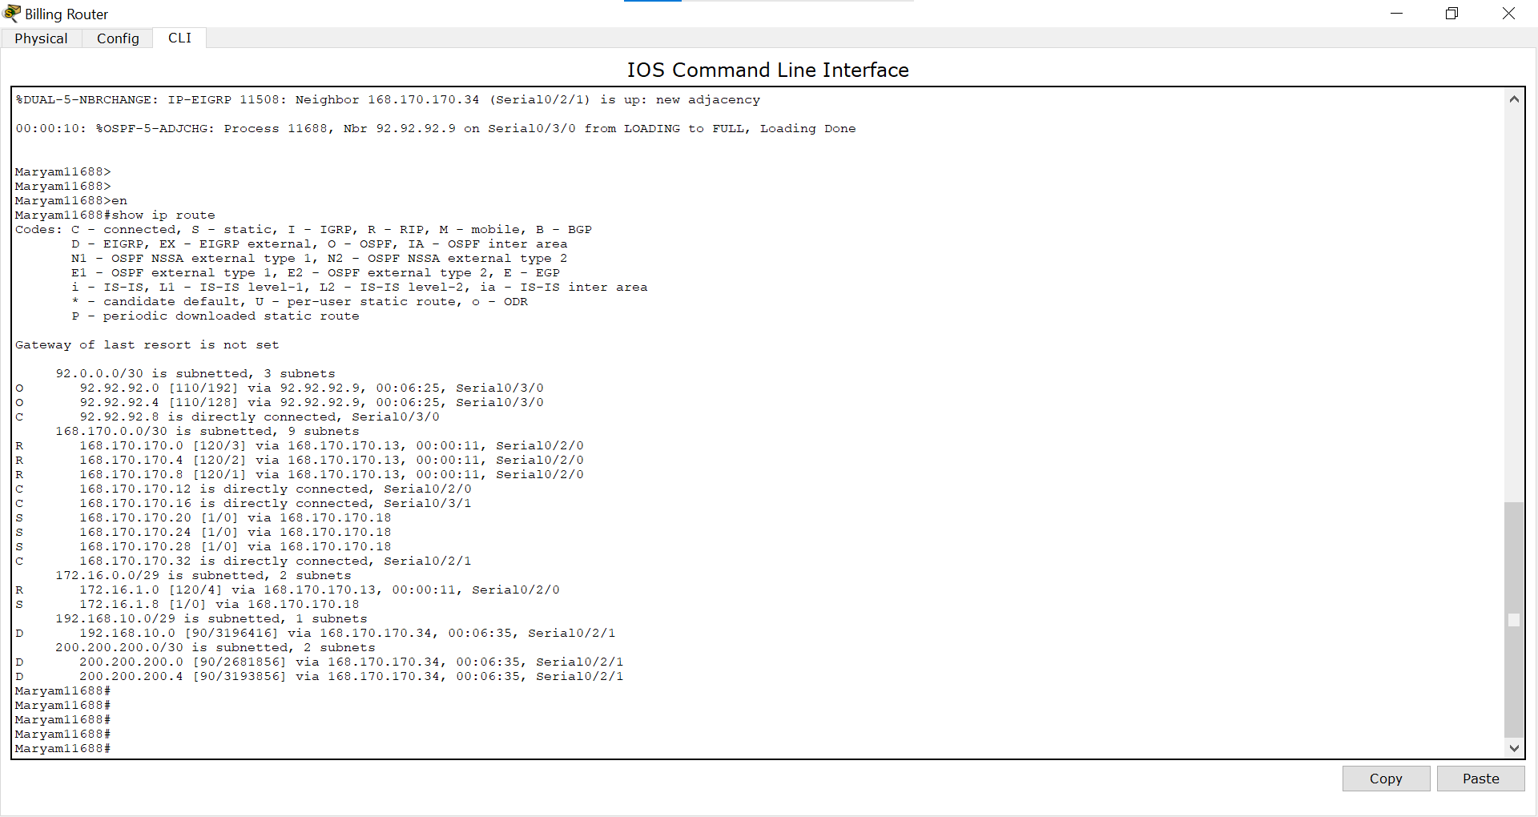

*Pharmacy Router:*

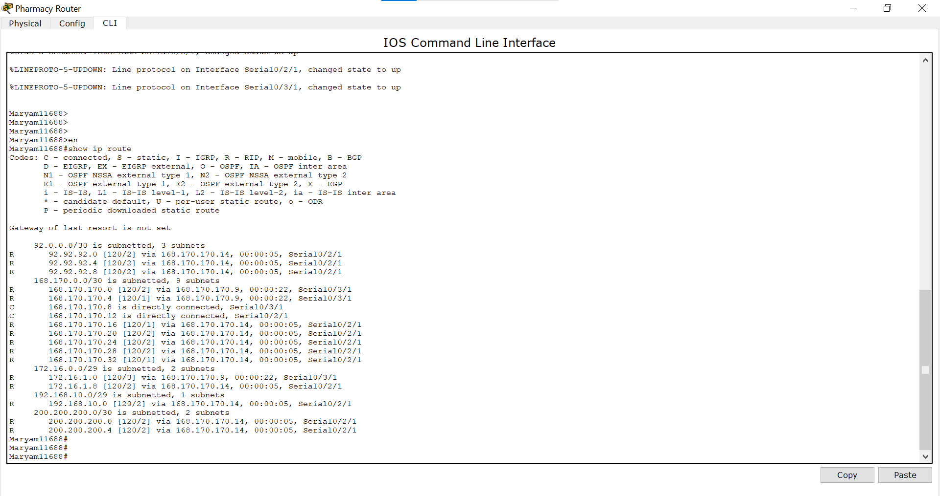

*Lab Router:*

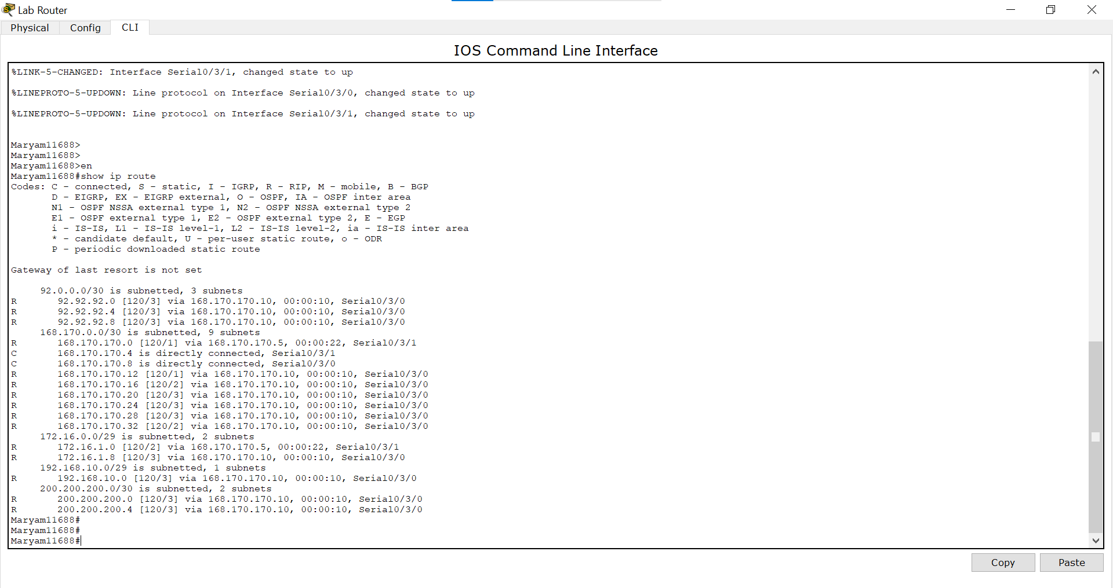

*Nurse Router:*

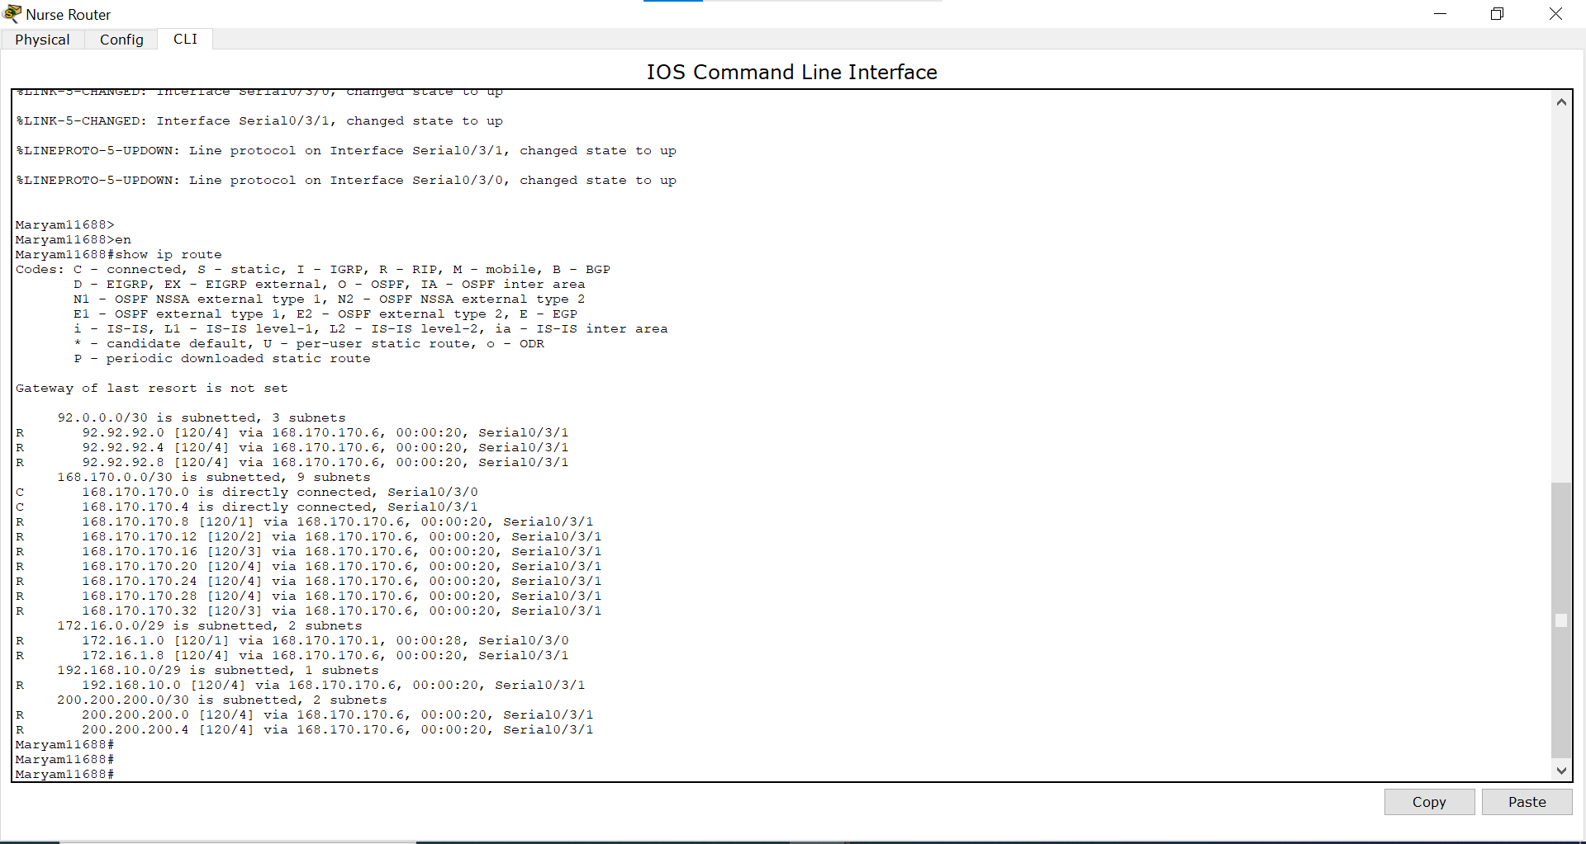

*Doctor Router:*

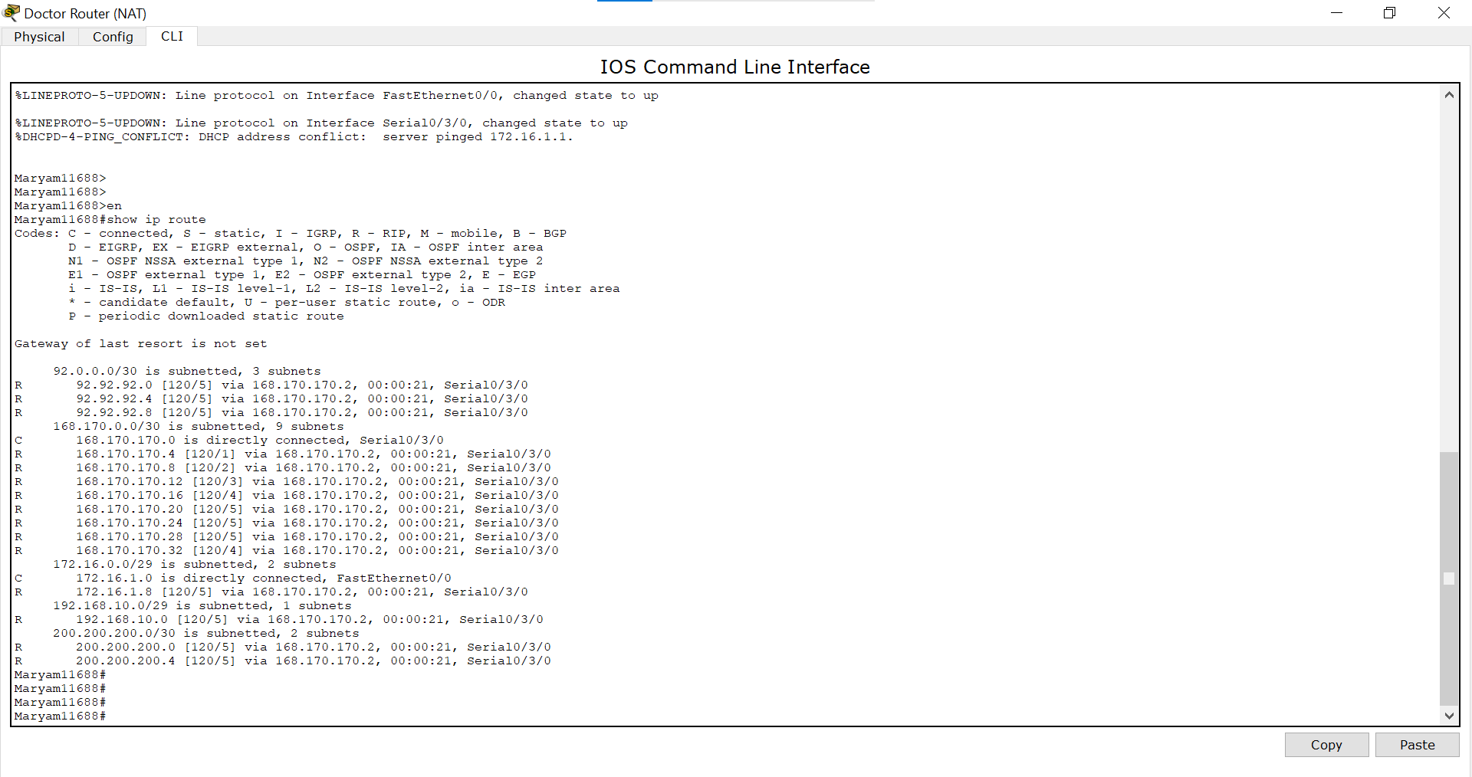

*Security Router:*

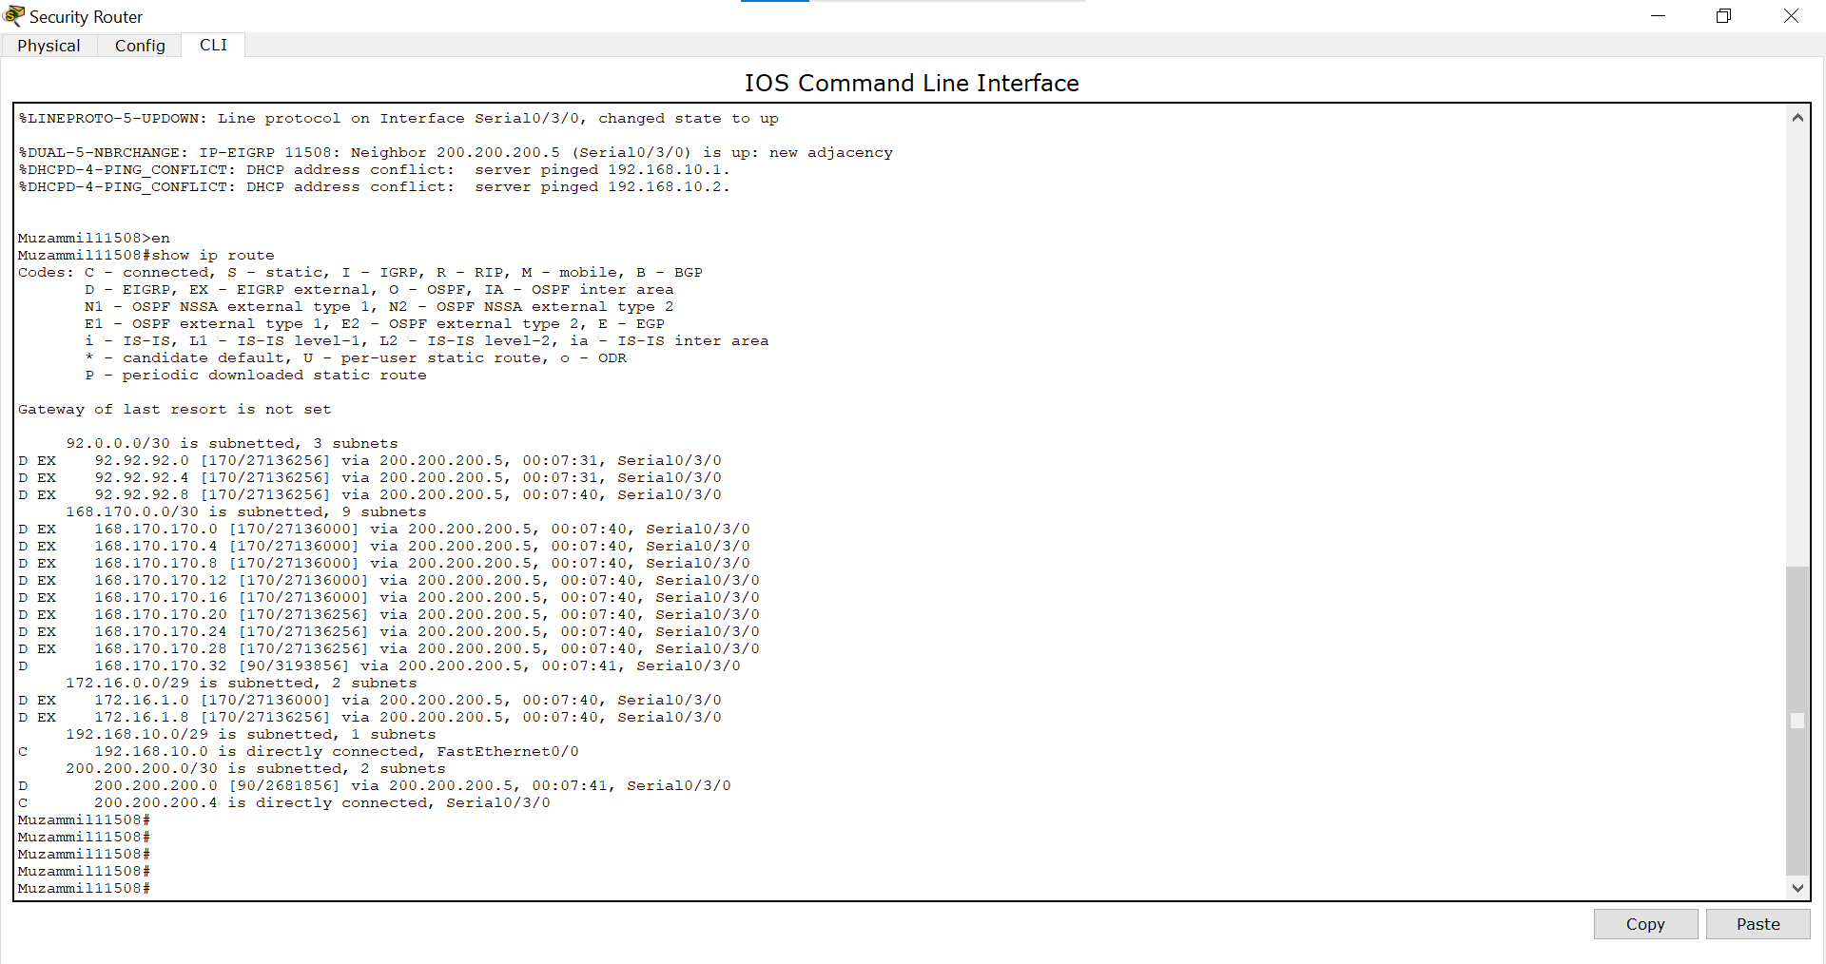

*Maintenance Router:*

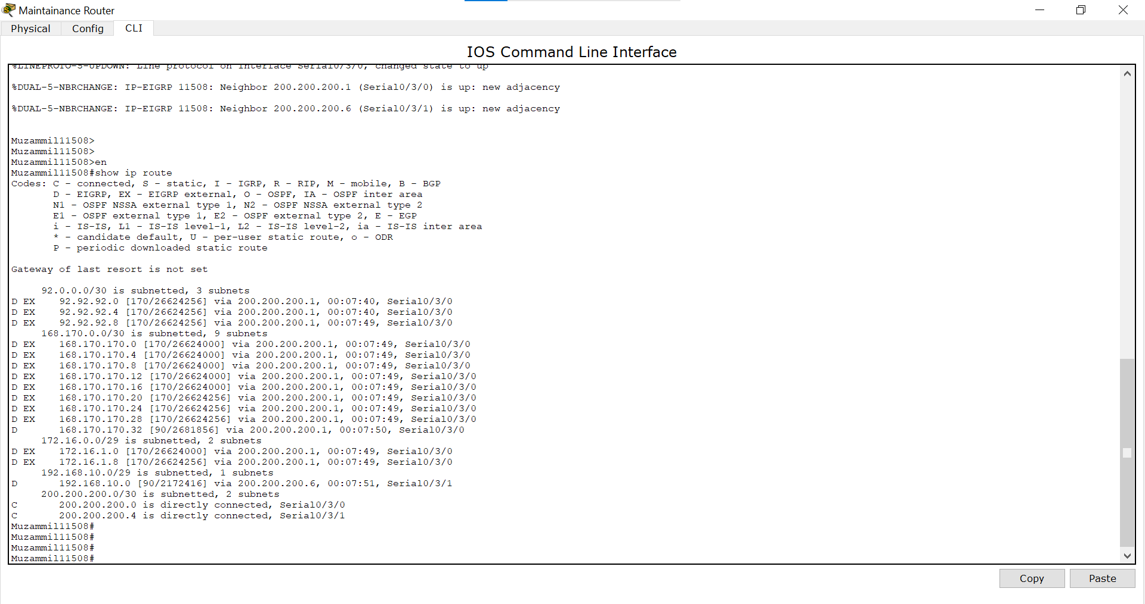

*IT Router:*

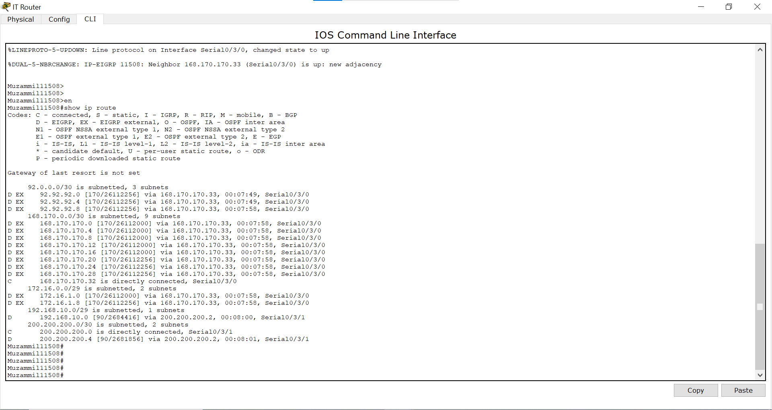

## 

## **Show Running Configuration:**

*Patient Router:*

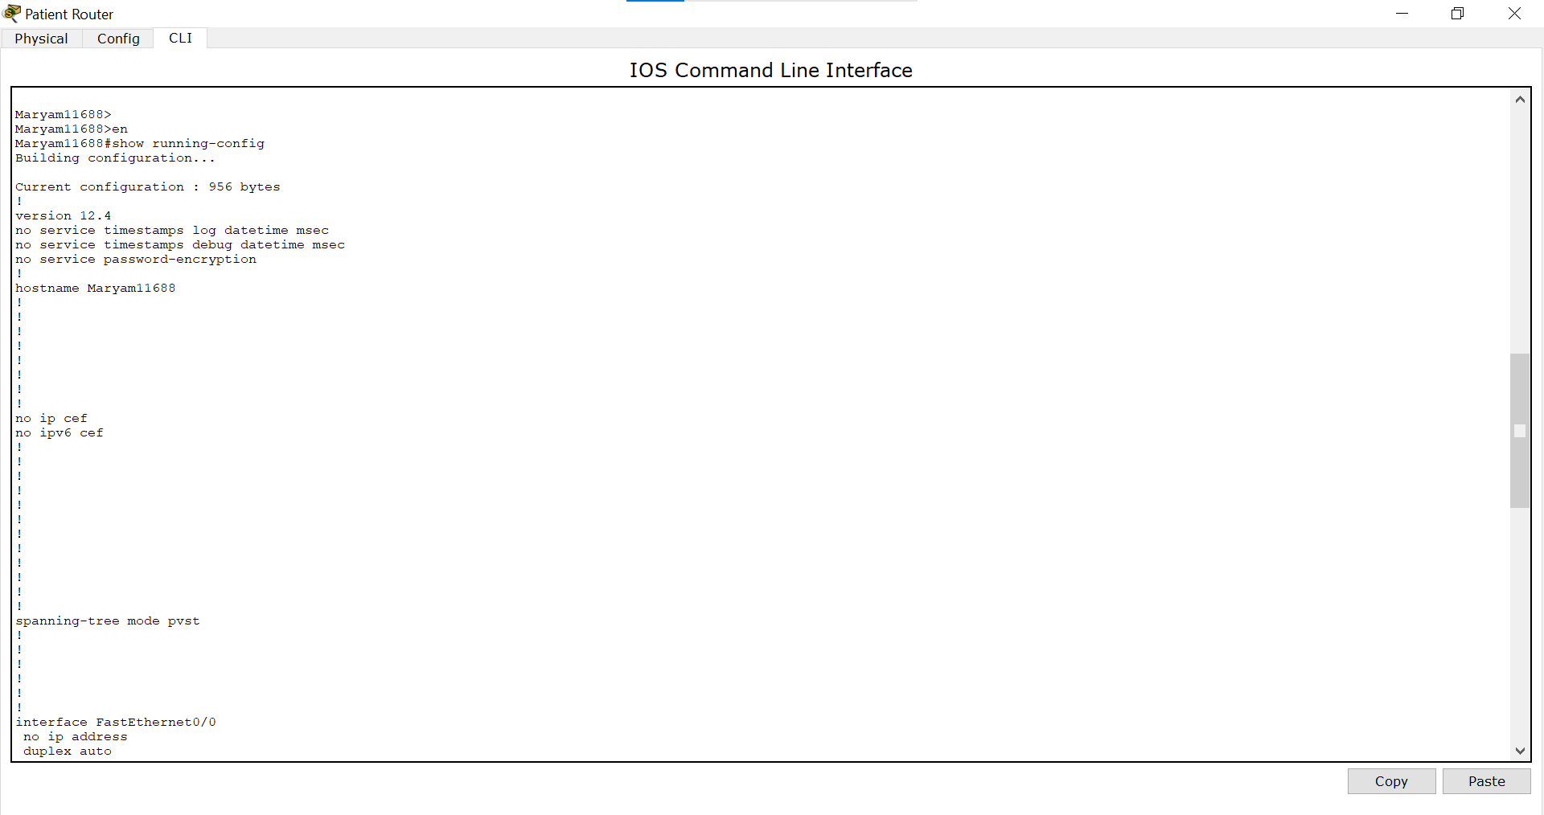

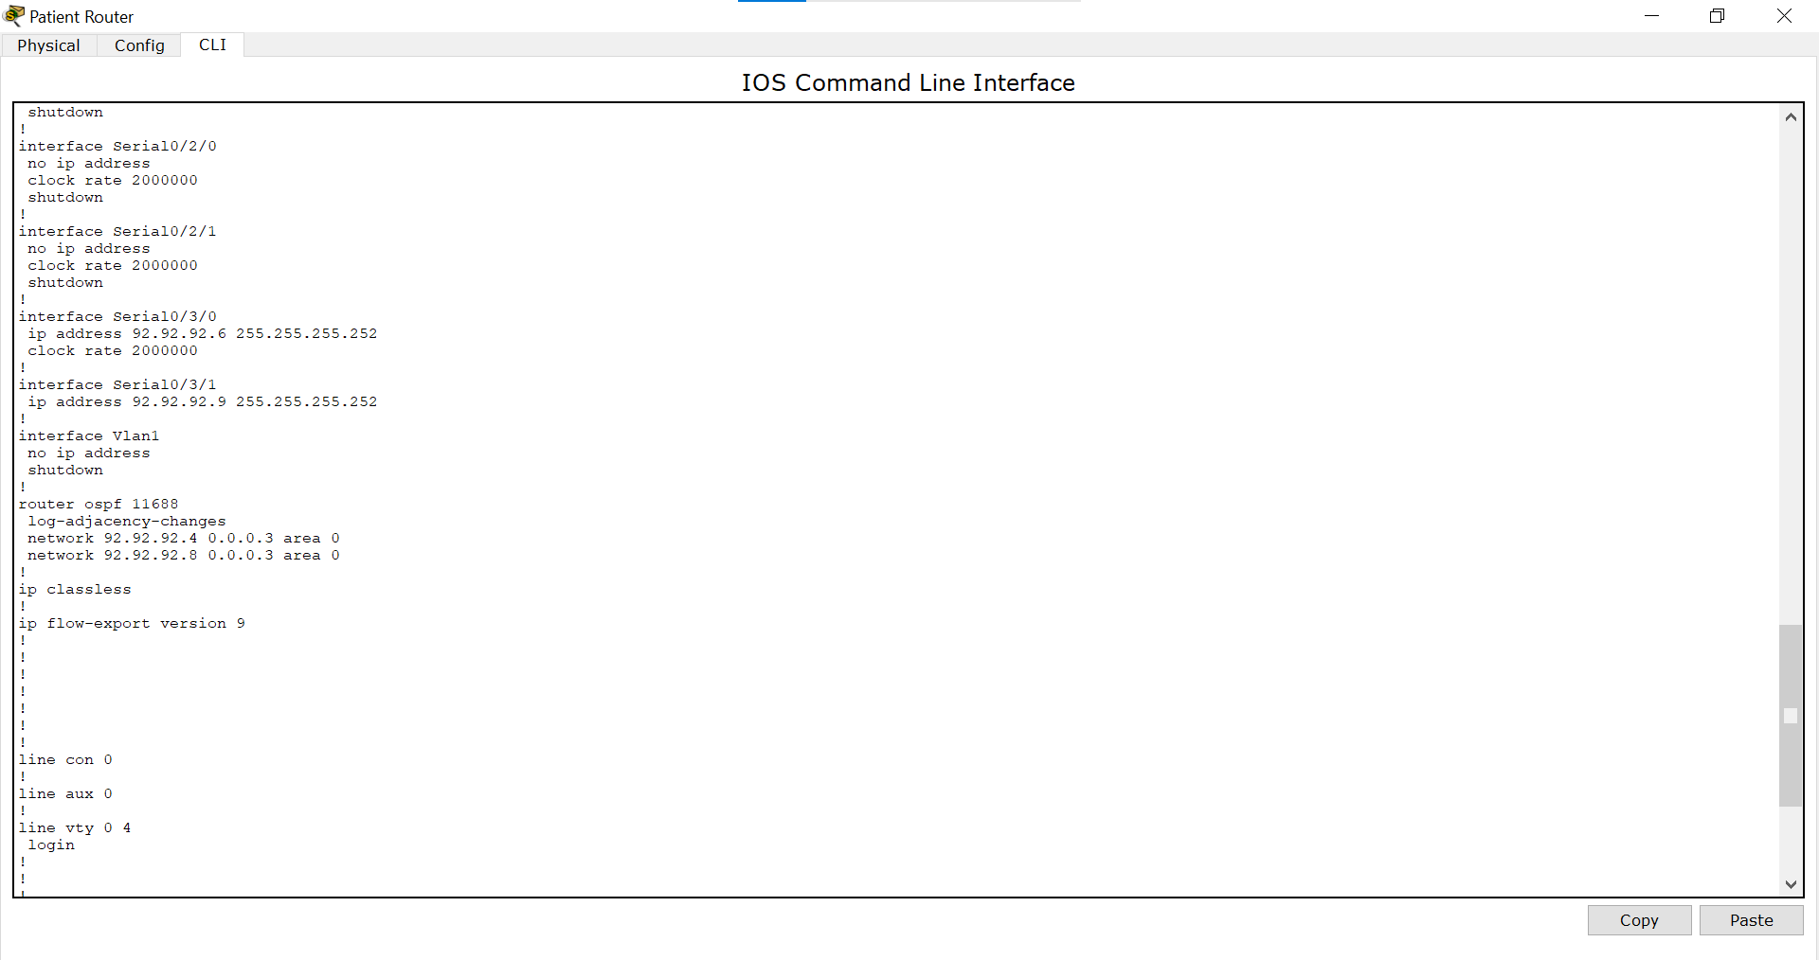

*Admin Router:*

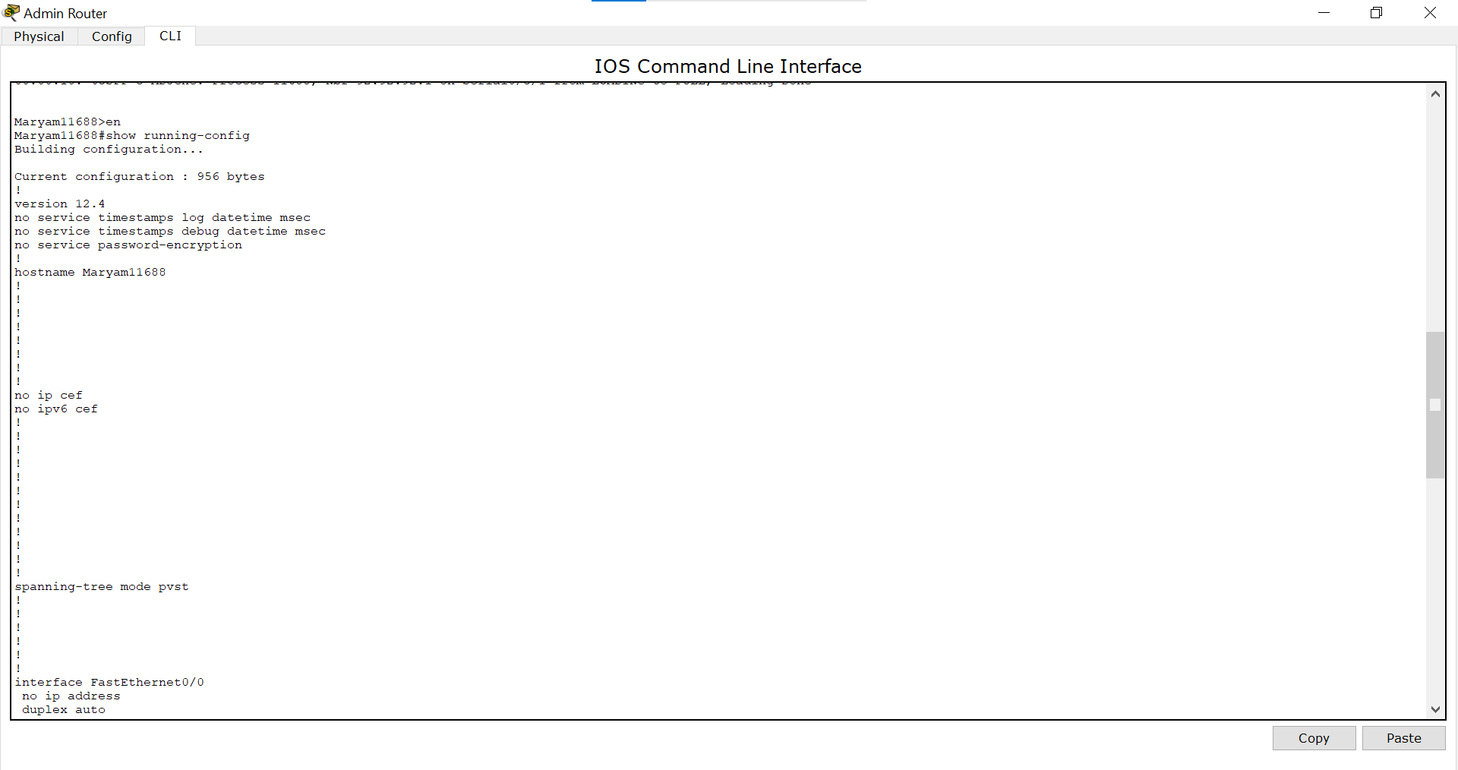

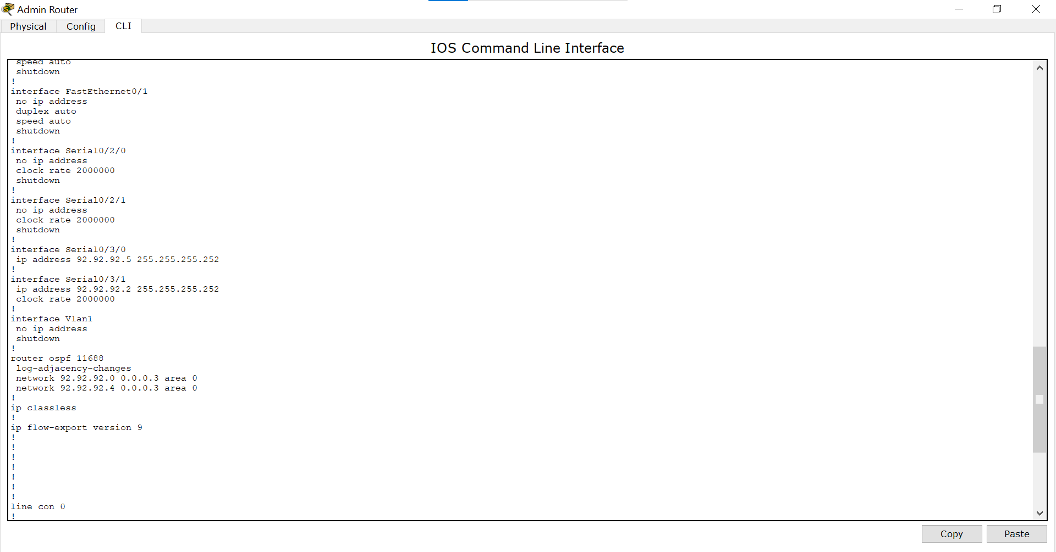

*Reception Router:*

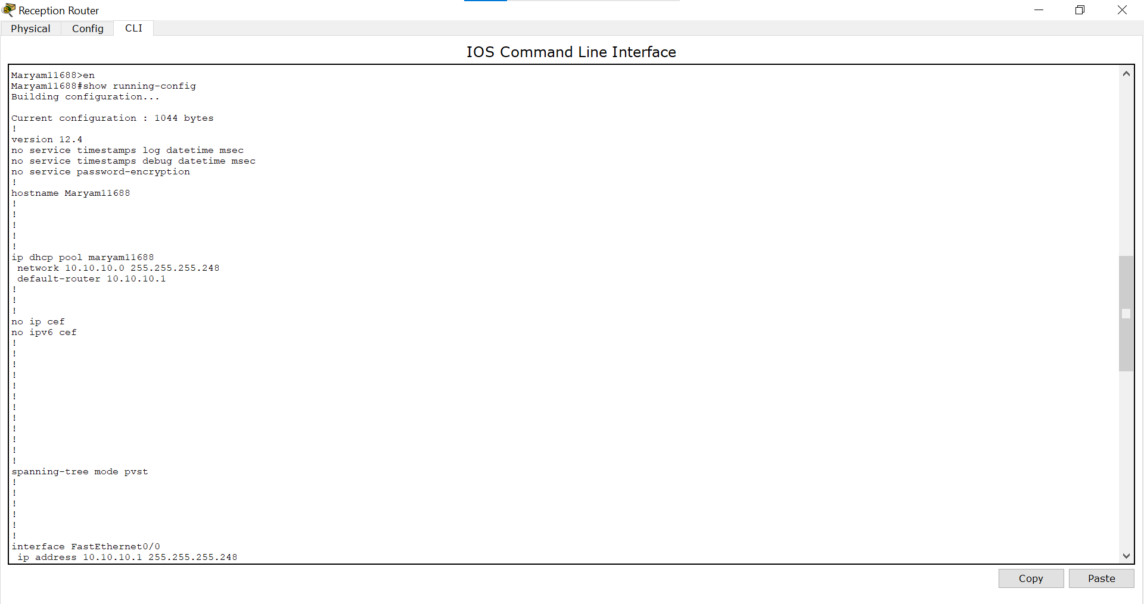

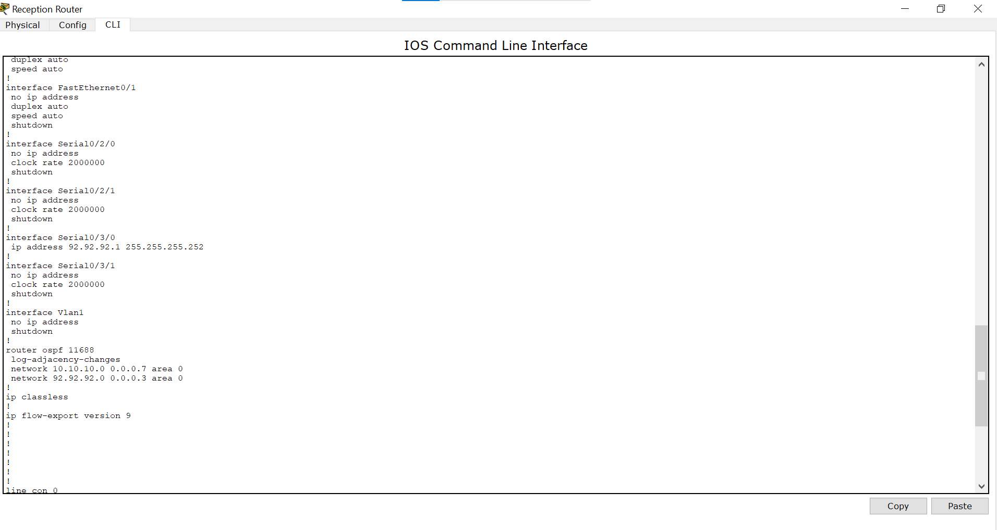

*Ambulance Router:*

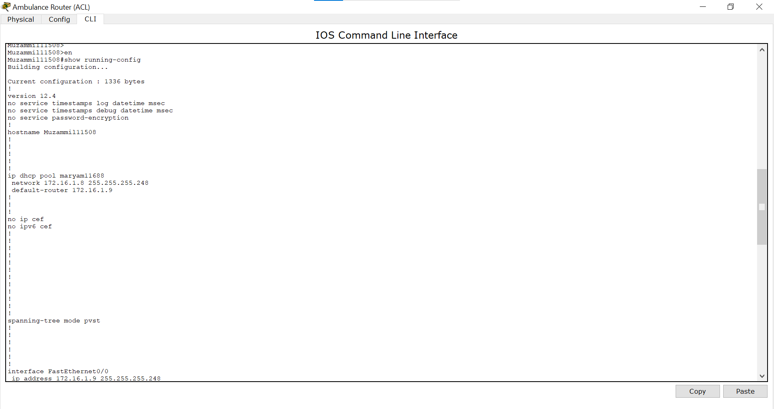

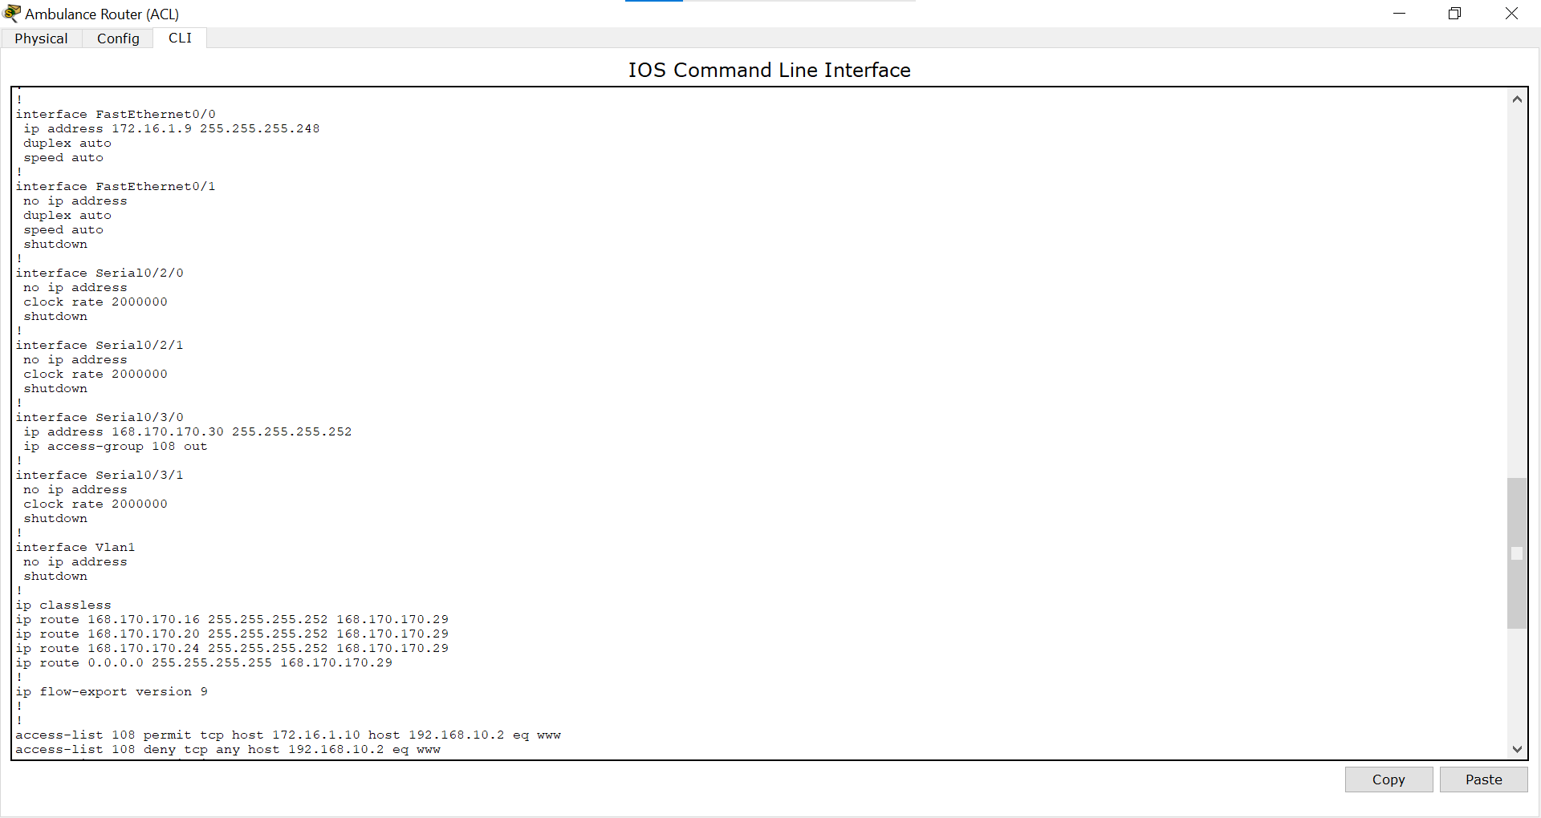

*Emergency Router:*

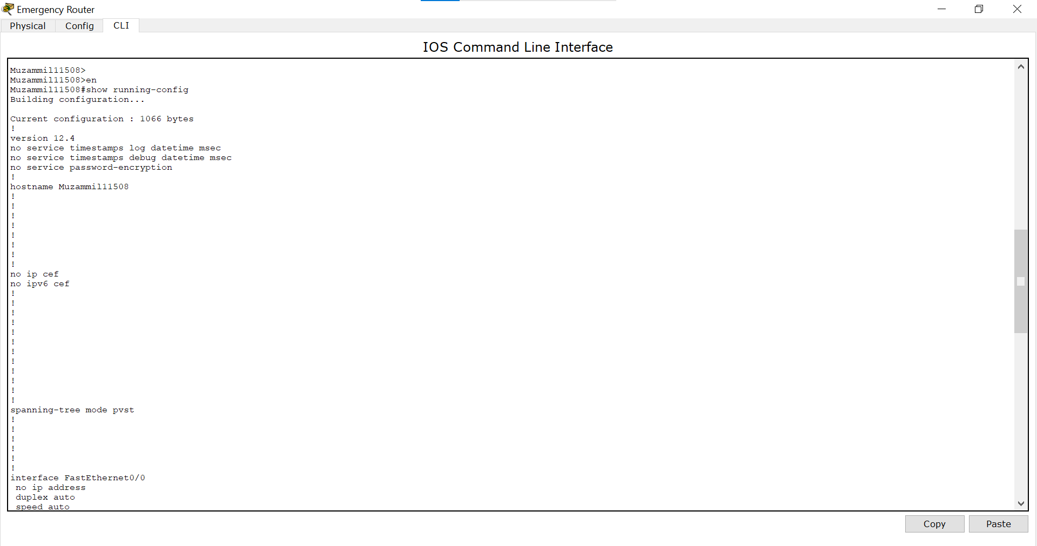

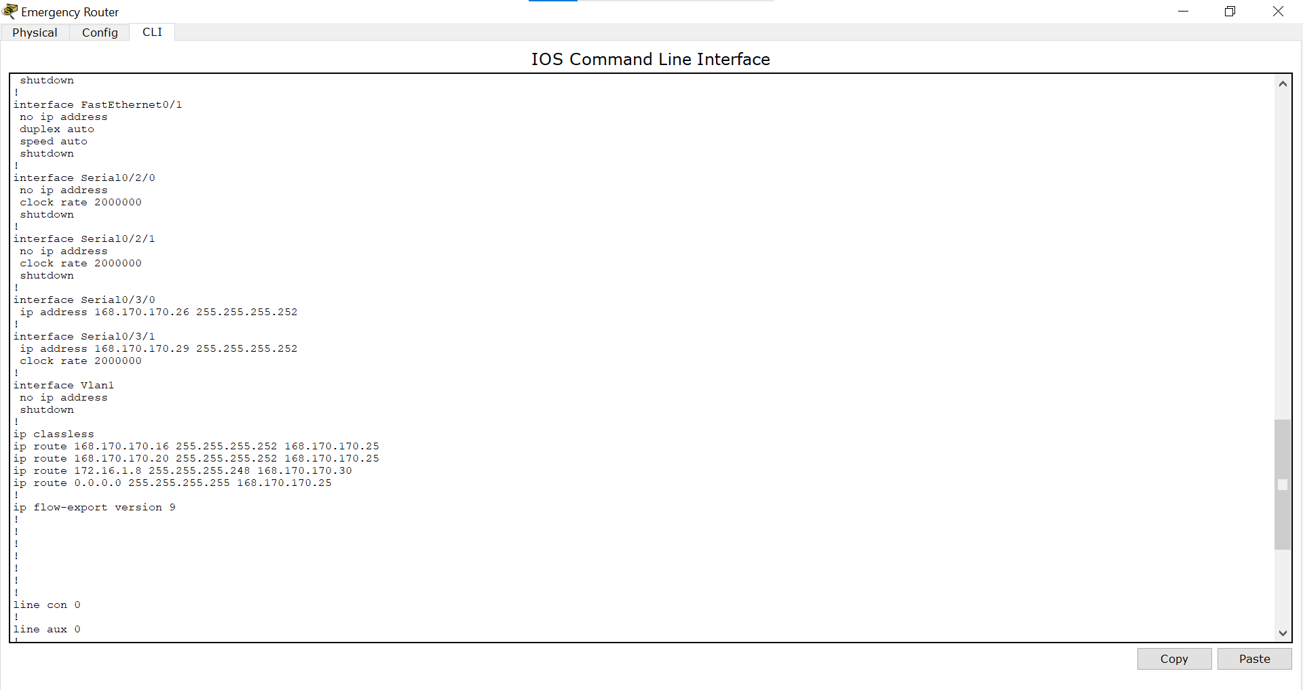

*Imaging Router:*

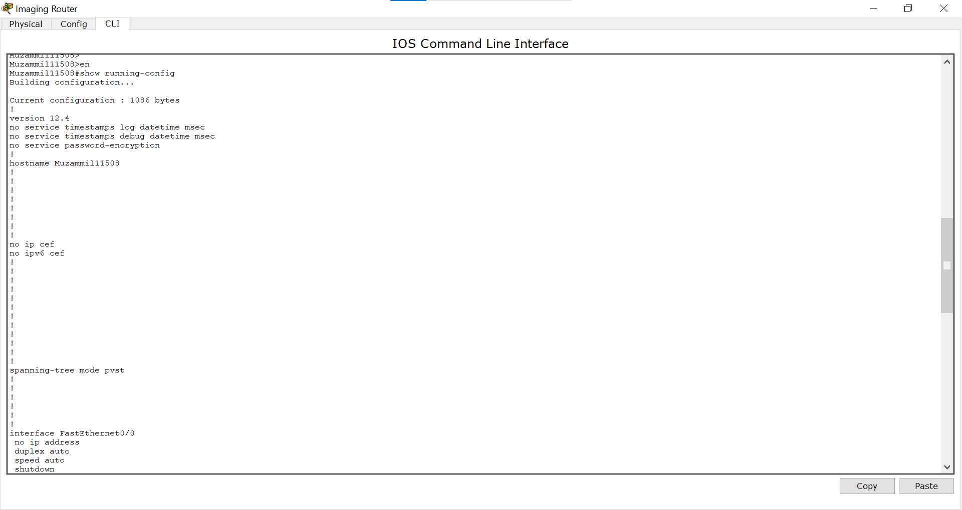

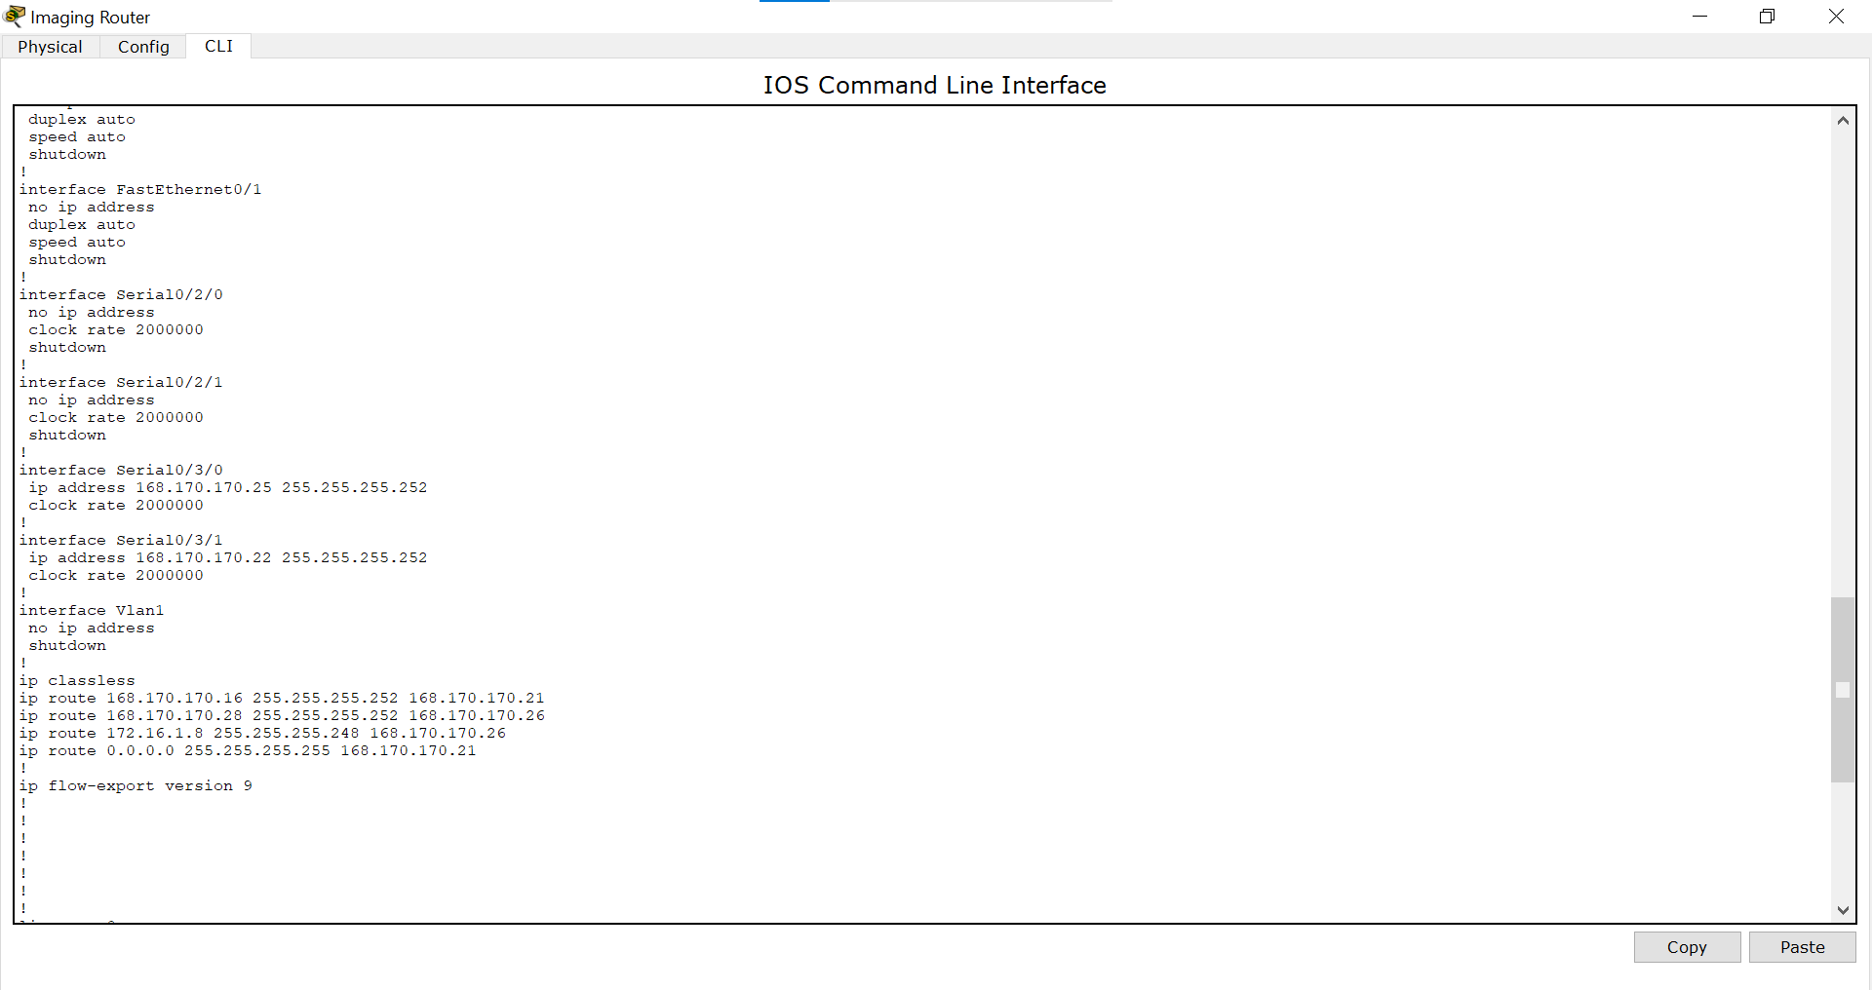

*Billing Router:*

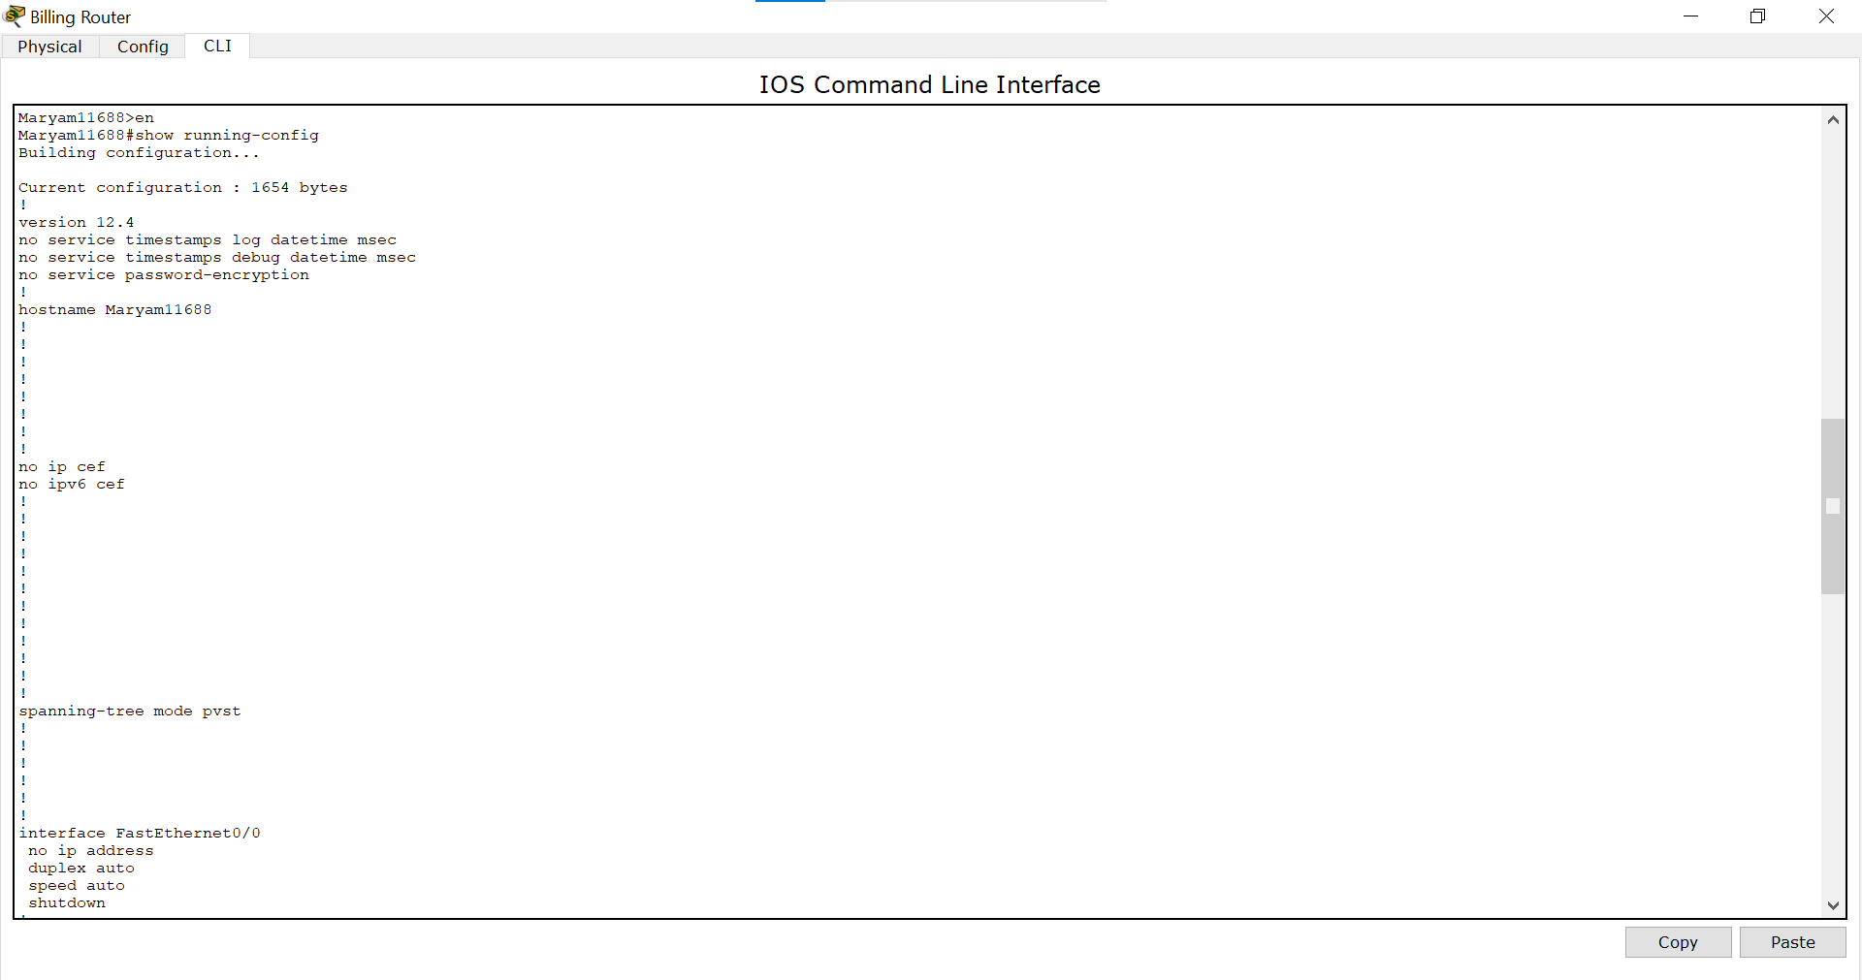

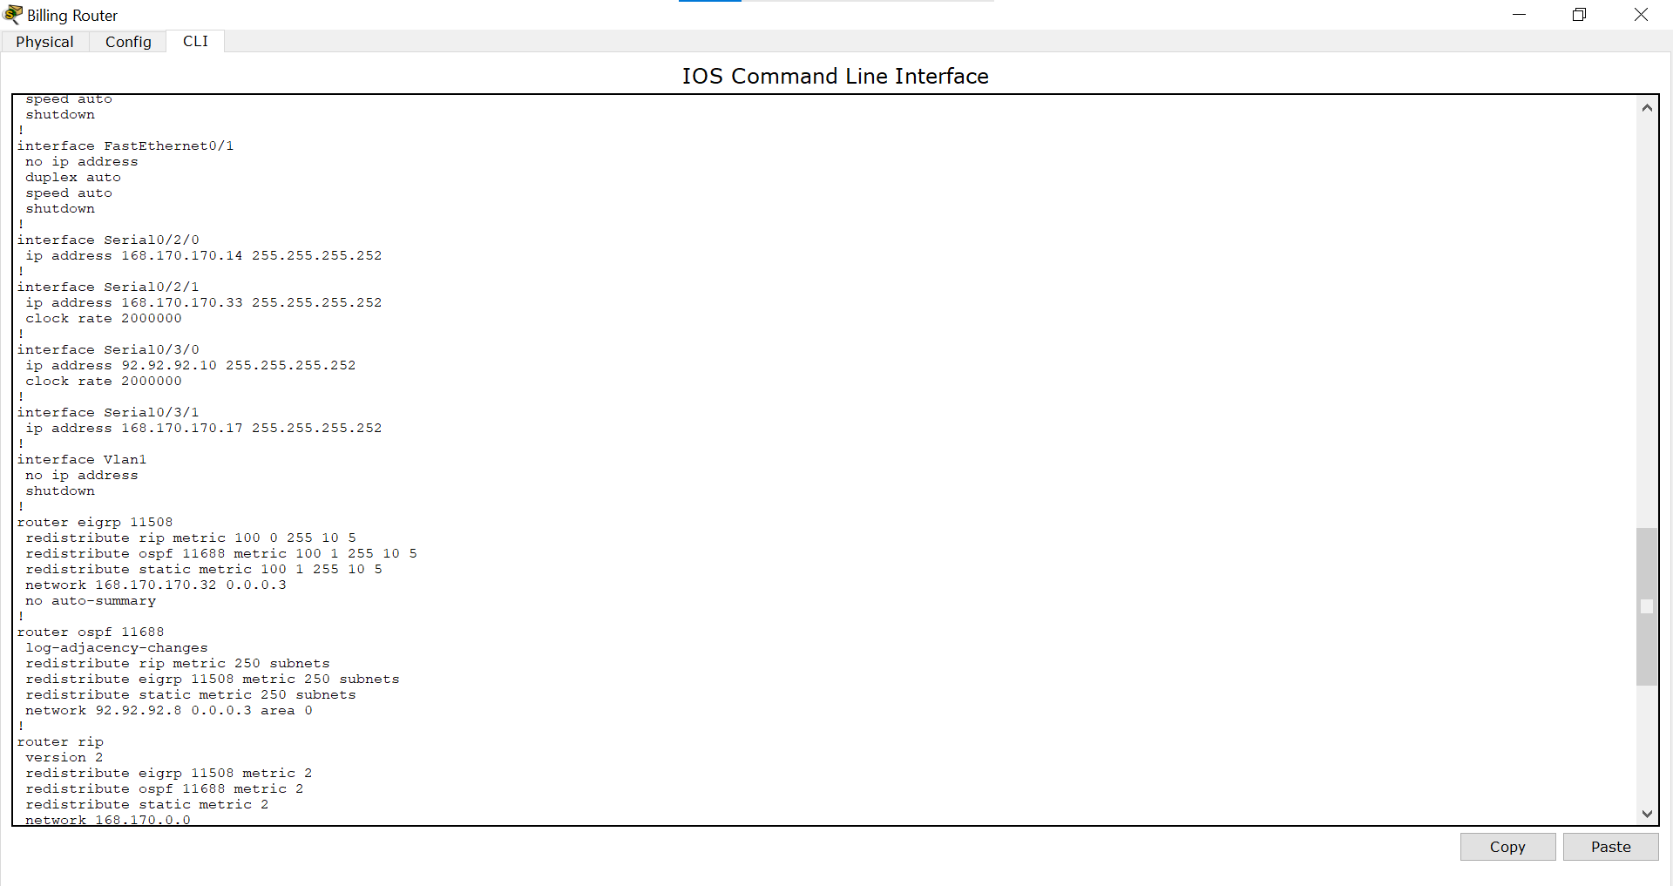

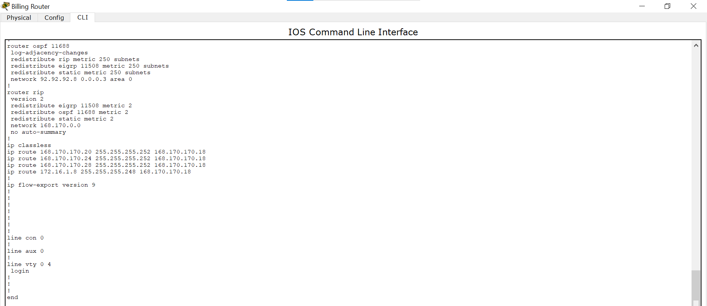

*Surgery Router:*

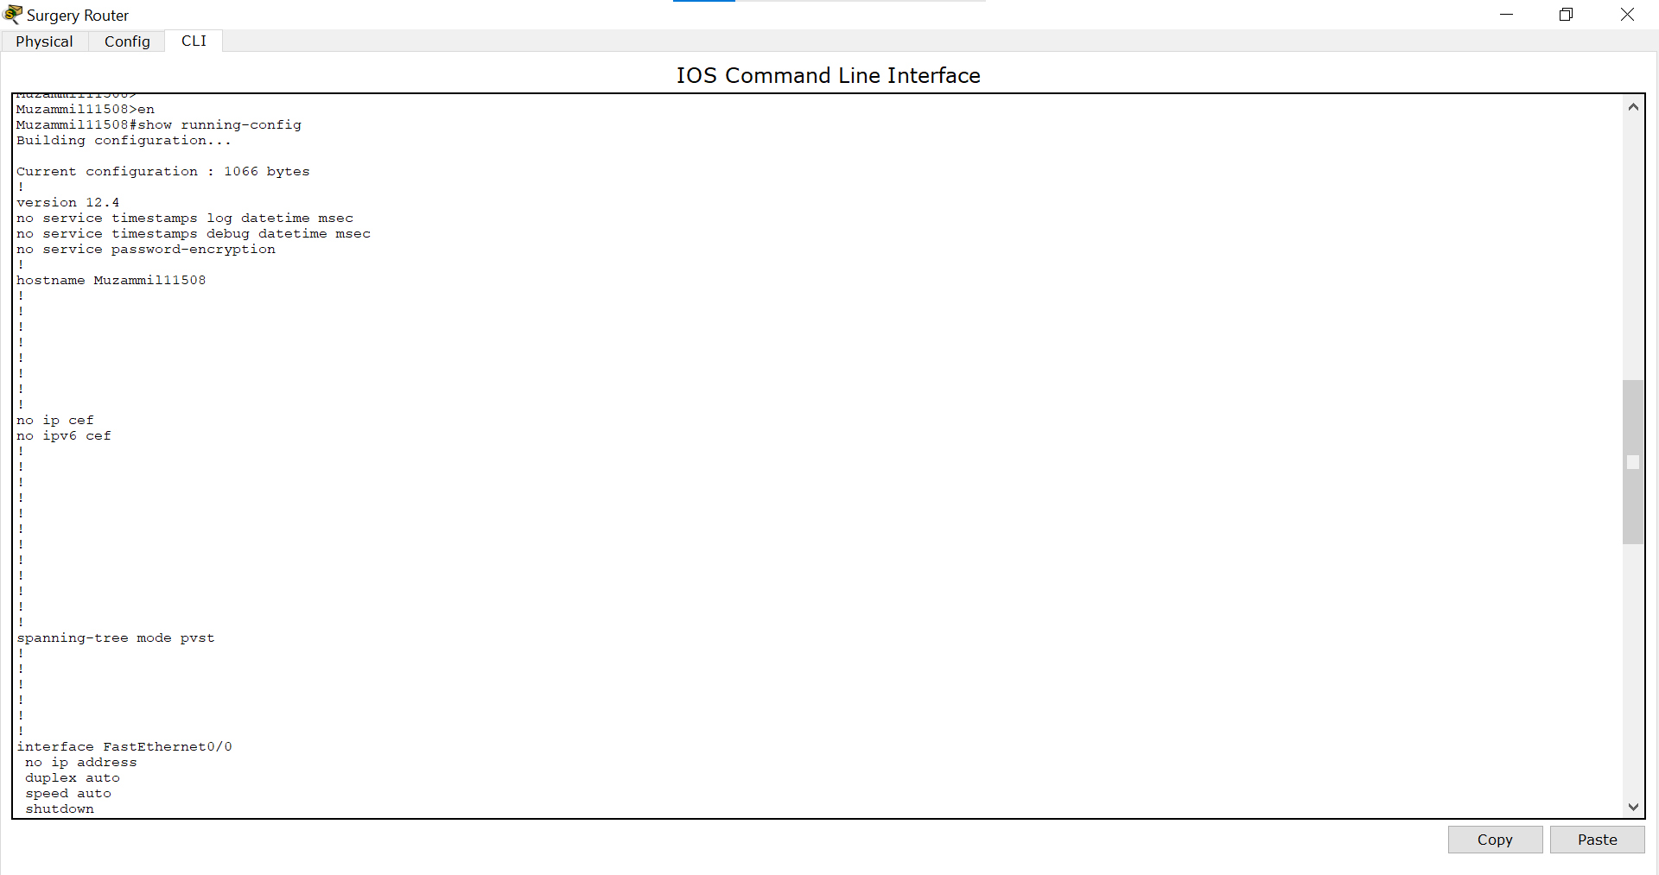

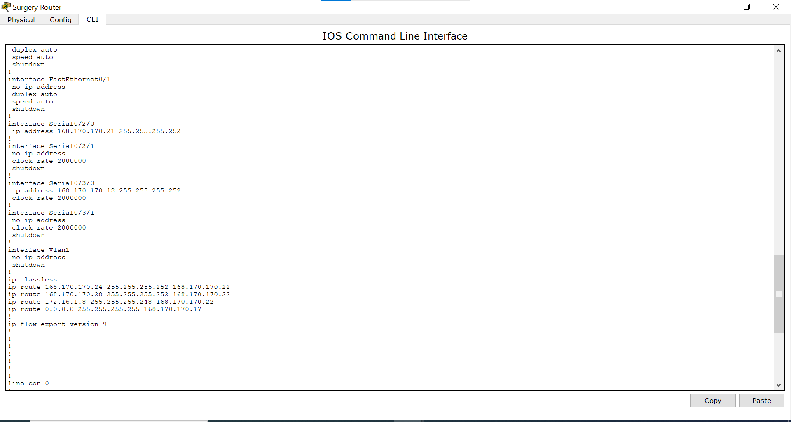

*Pharmacy Router:*

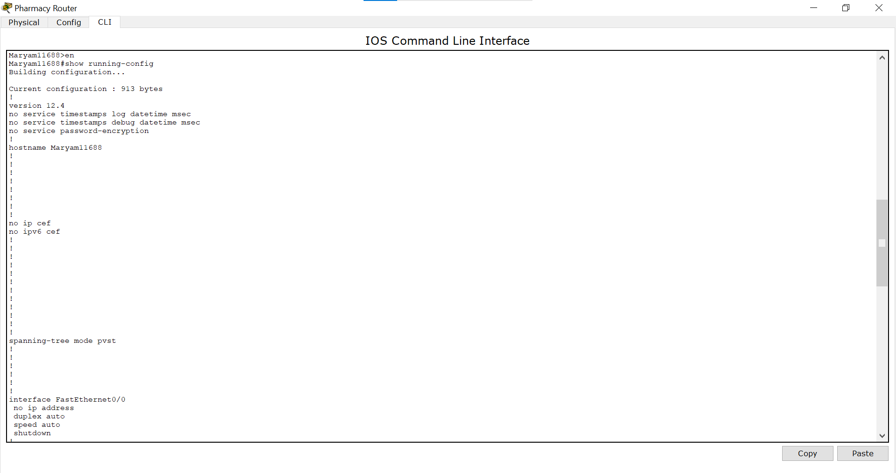

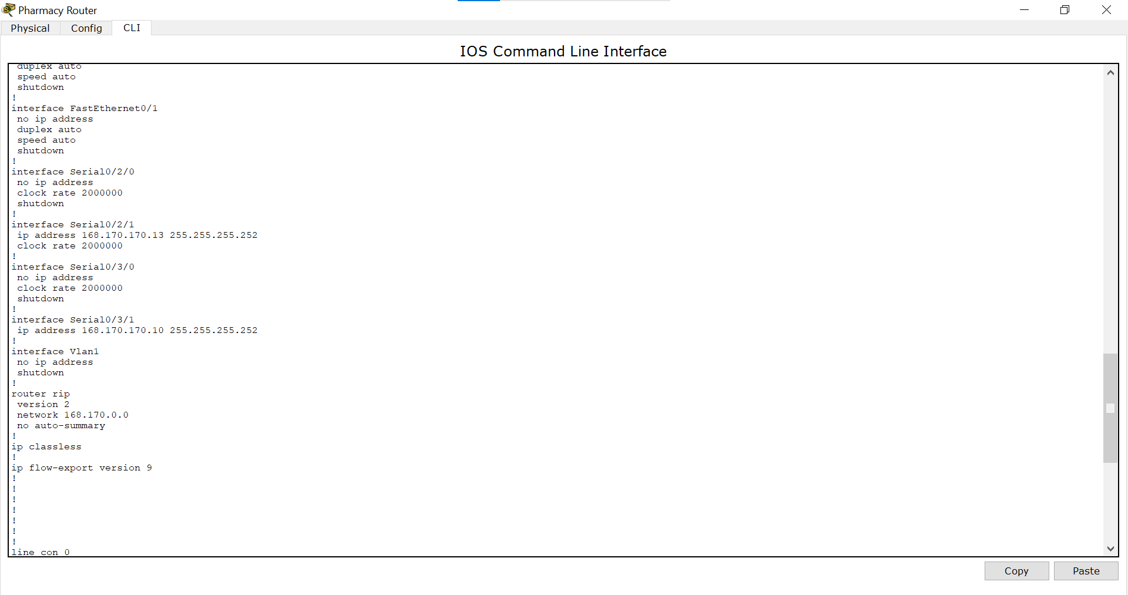

*Lab Router:*

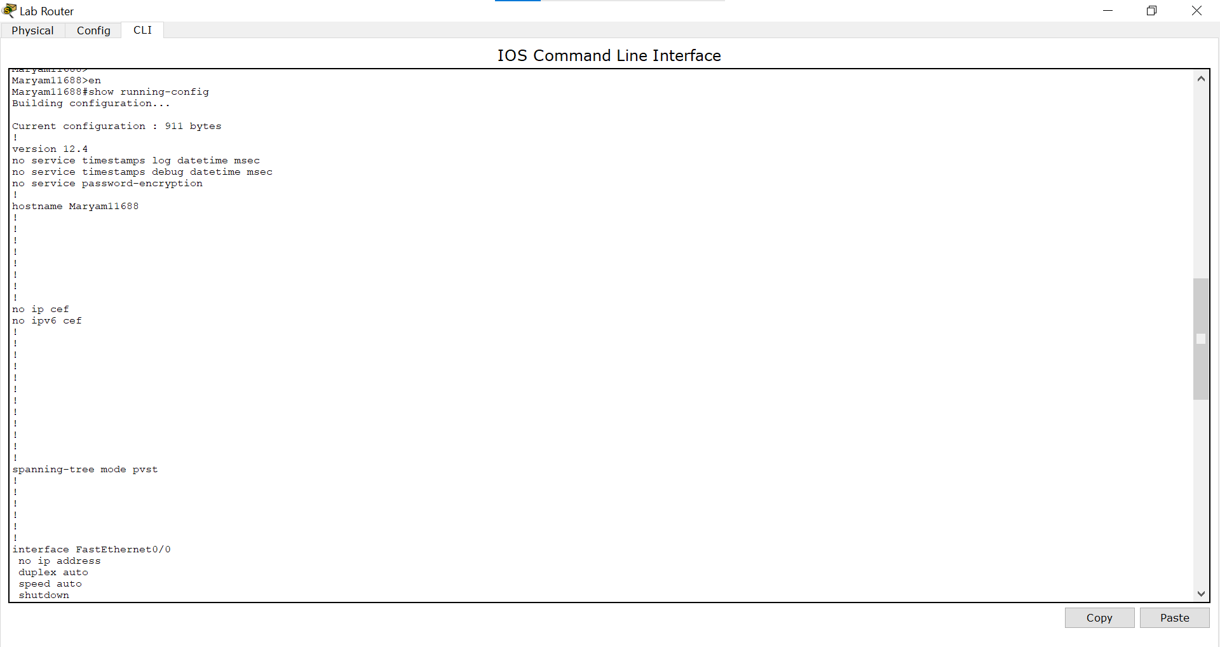

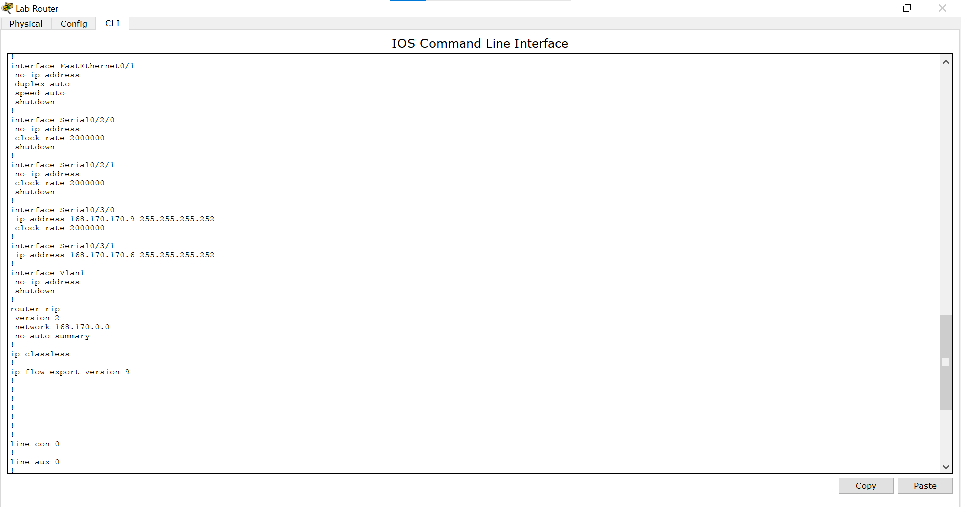

*Nurse Router:*

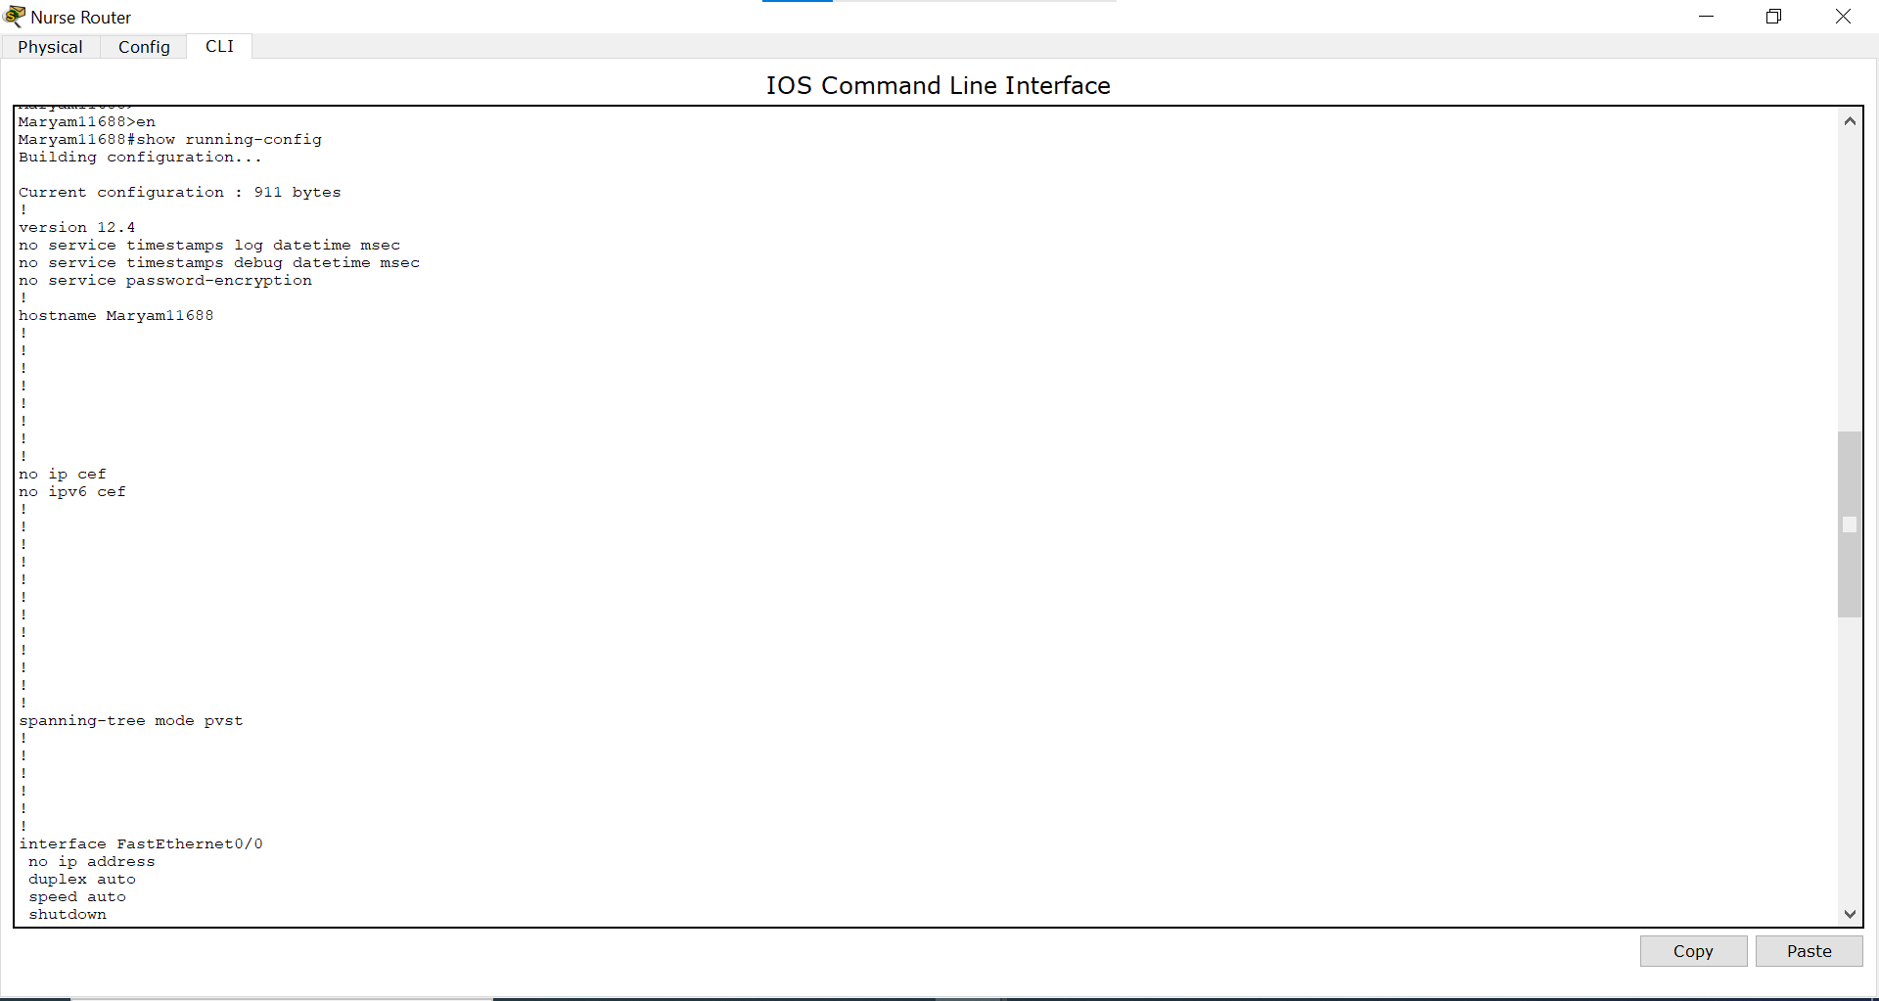

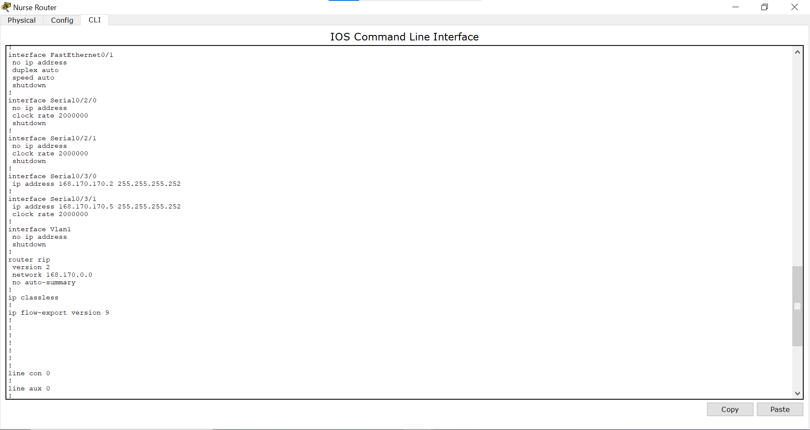

*Doctor Router:*

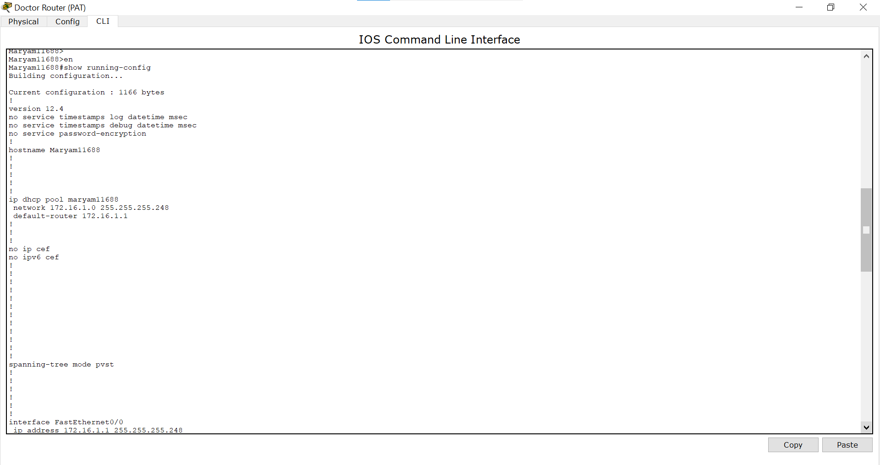

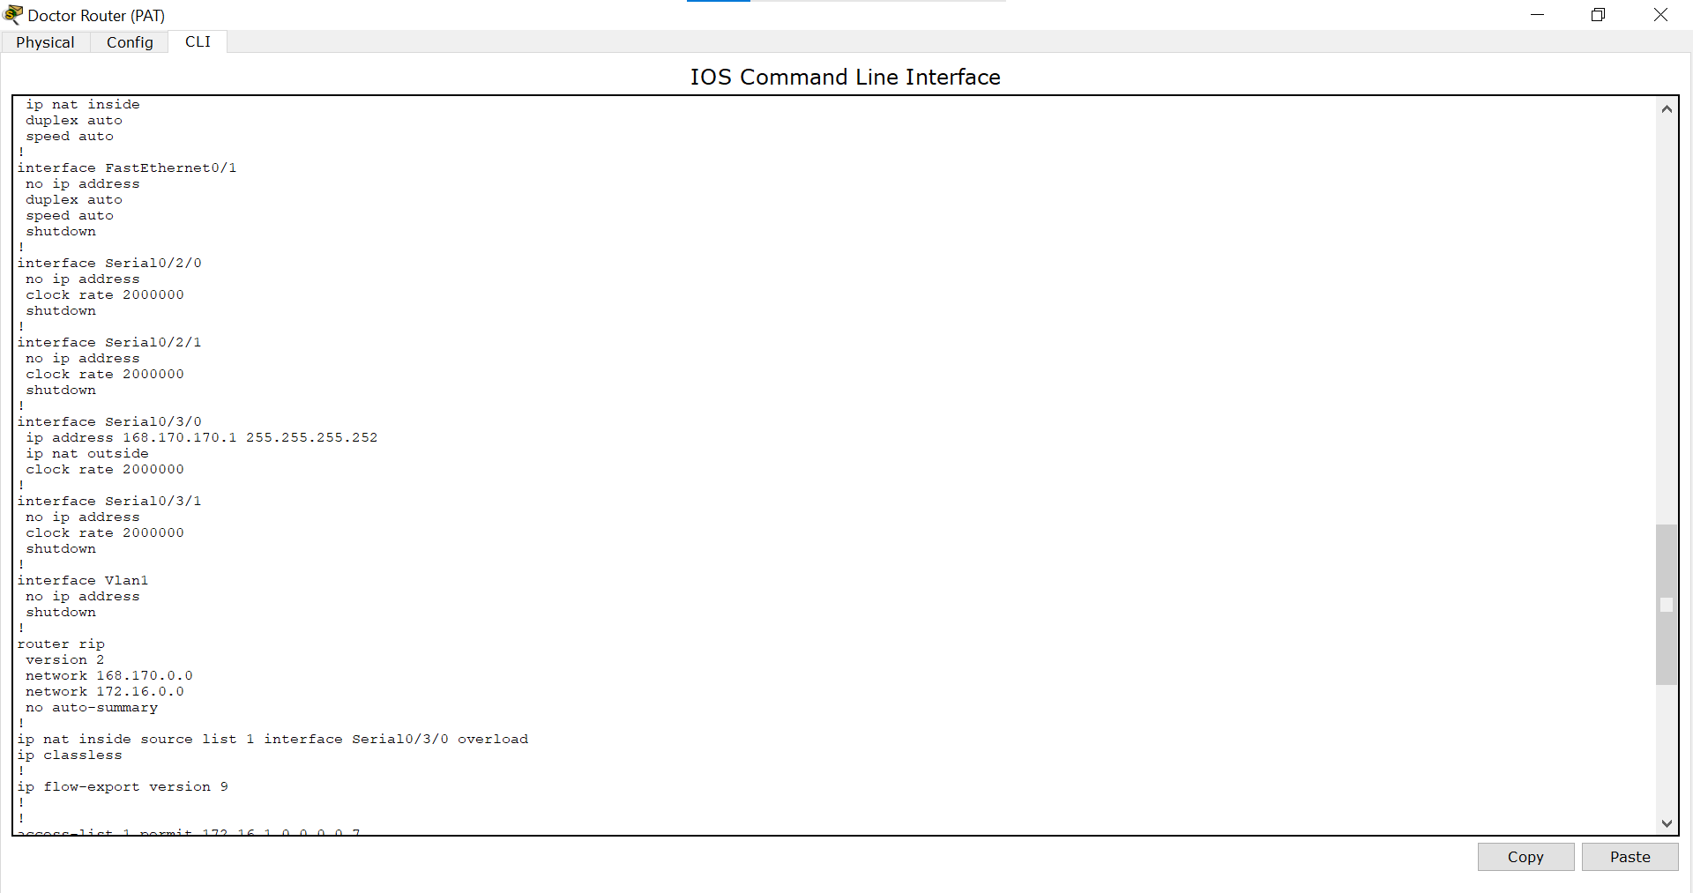

*Security Router:*

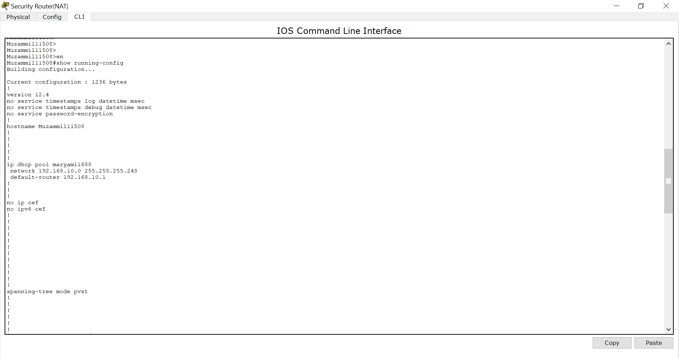

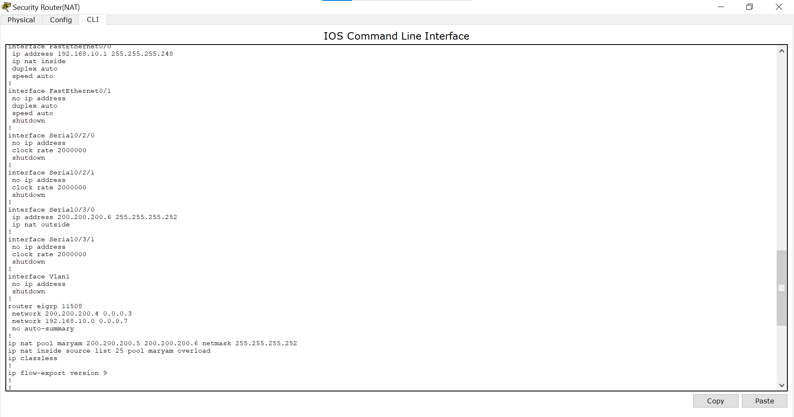

*Maintenance Router:*

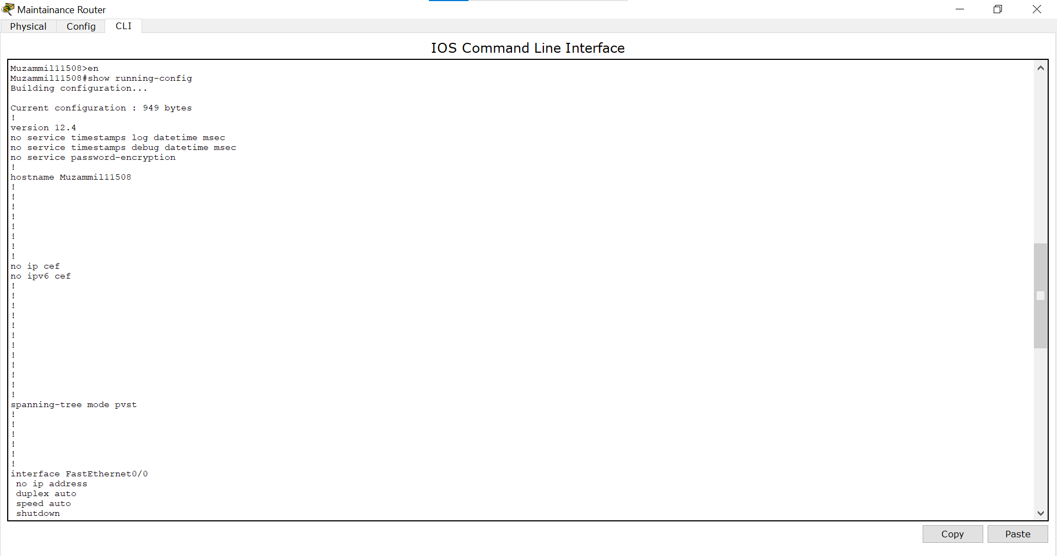

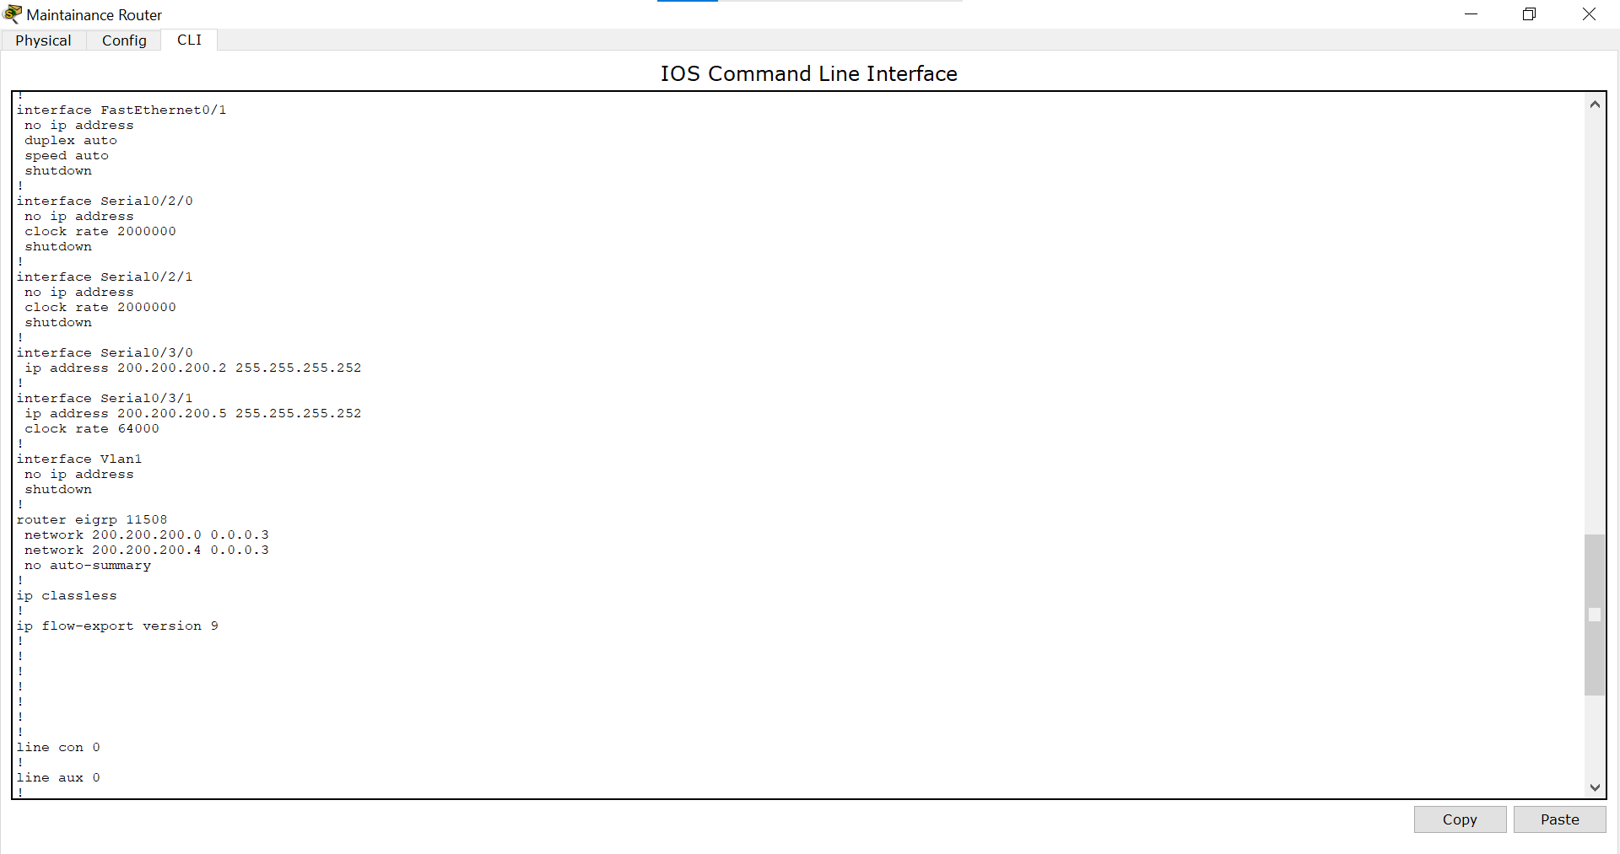

*IT Router:*

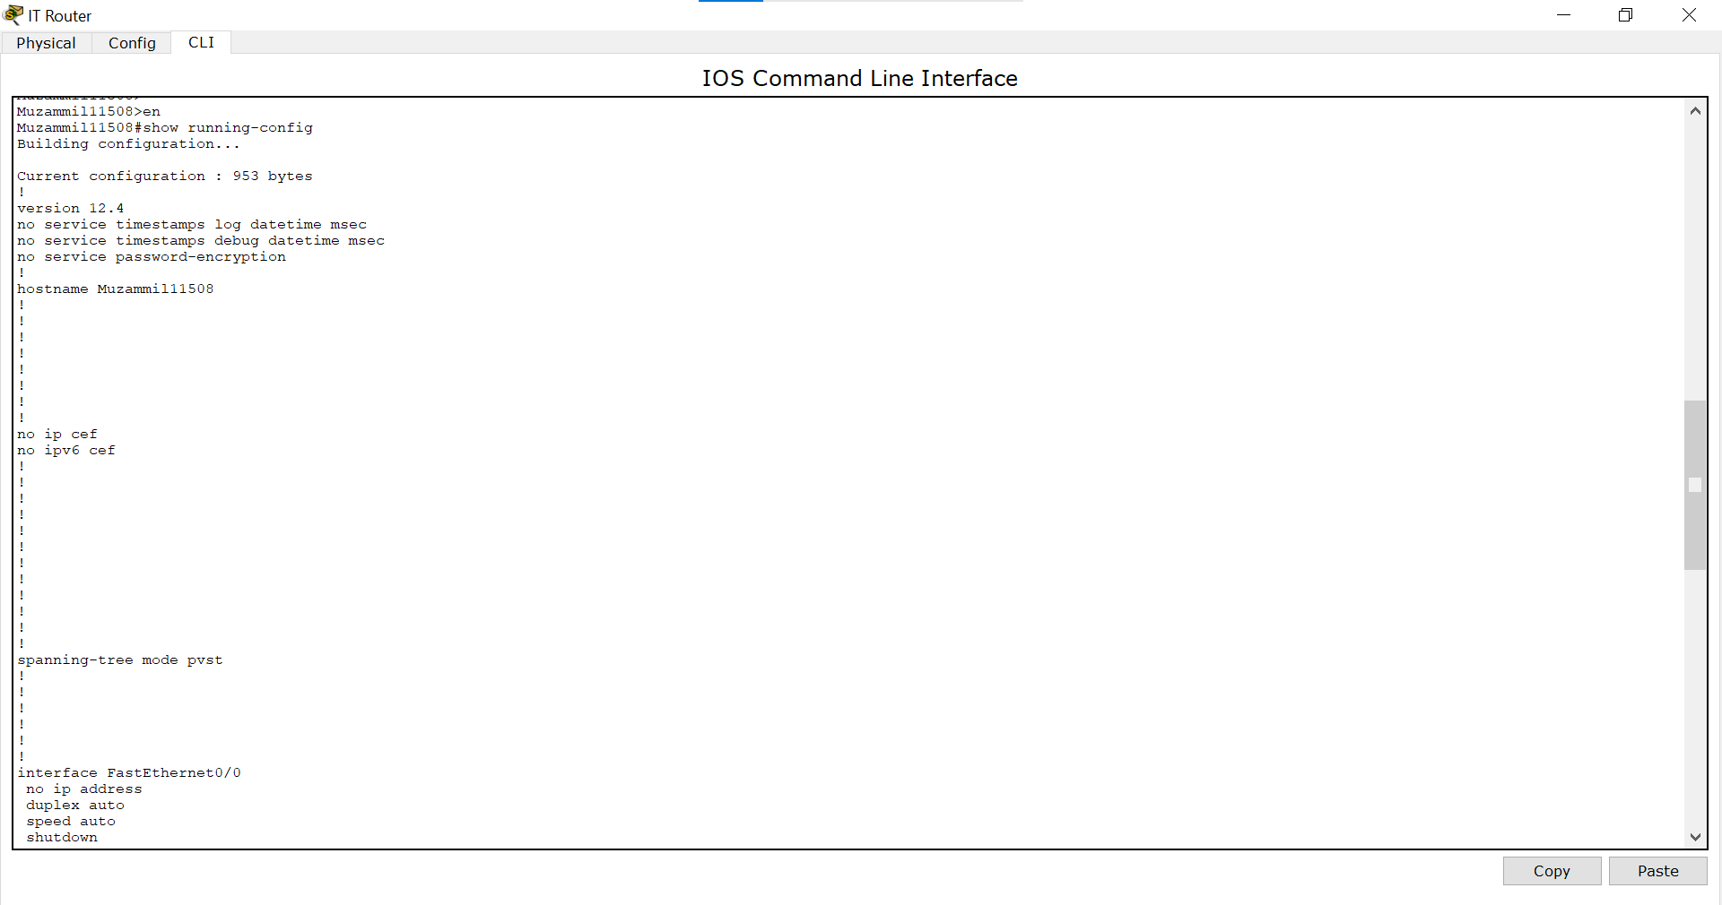

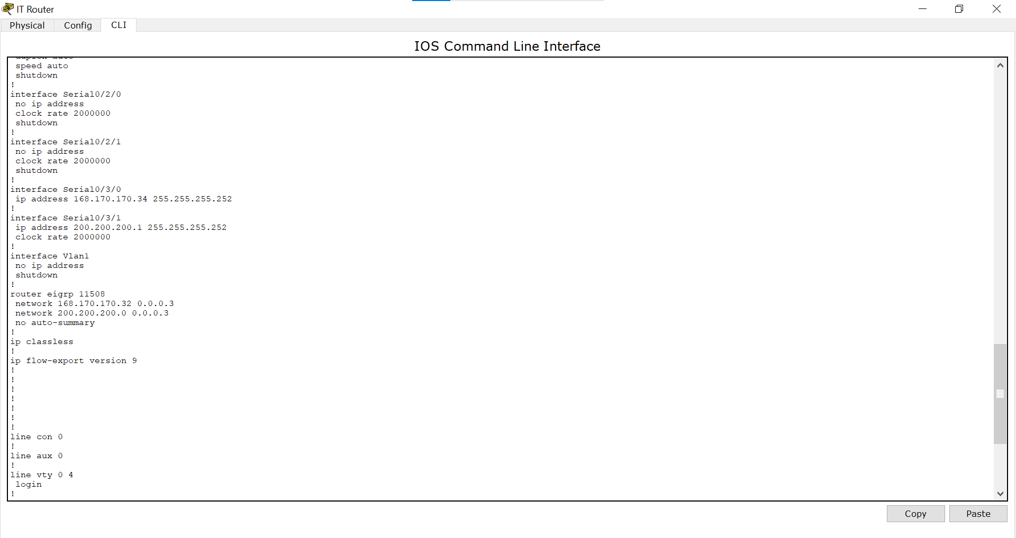

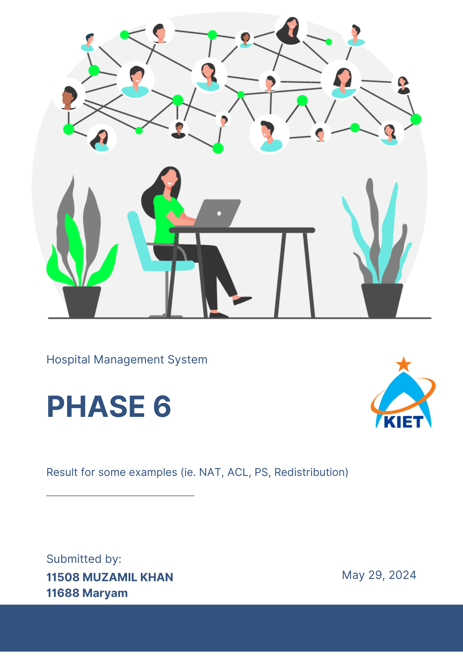

## **Result for some examples (i.e. NAT, ACL, PS, Redistribution):**

### **NAT:**

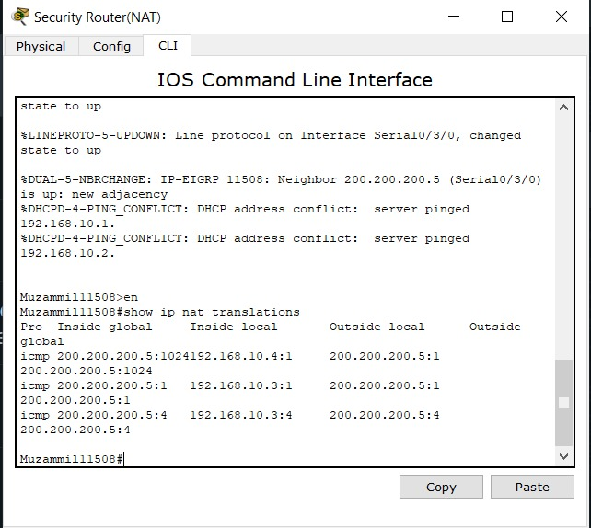

**PAT:**

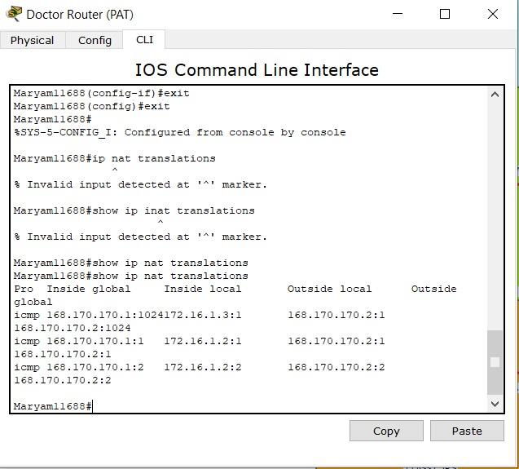

### **ACL:**

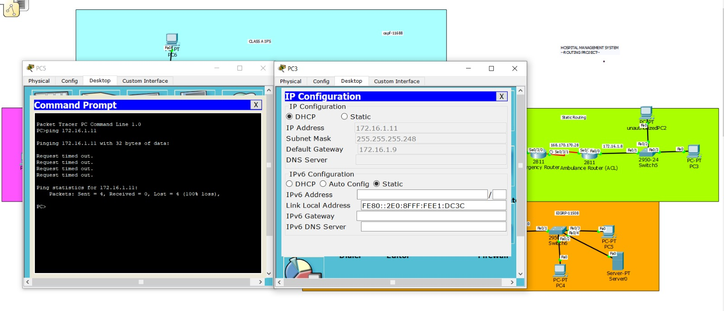

### **Port Security:**

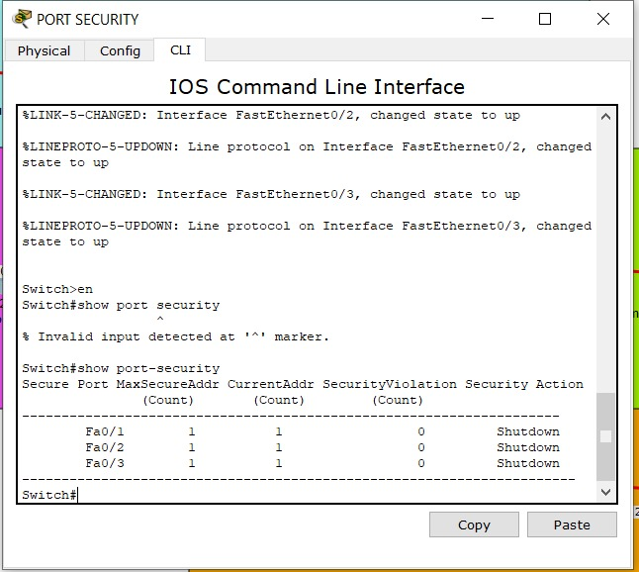

### **Redistribution:**

#### **From p0 to emergency router:**

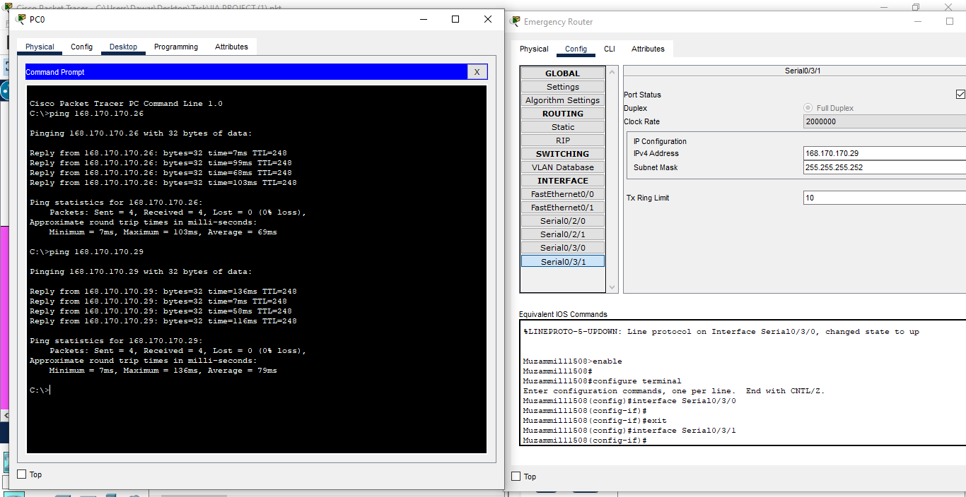

#### **From p1 to admin router:**

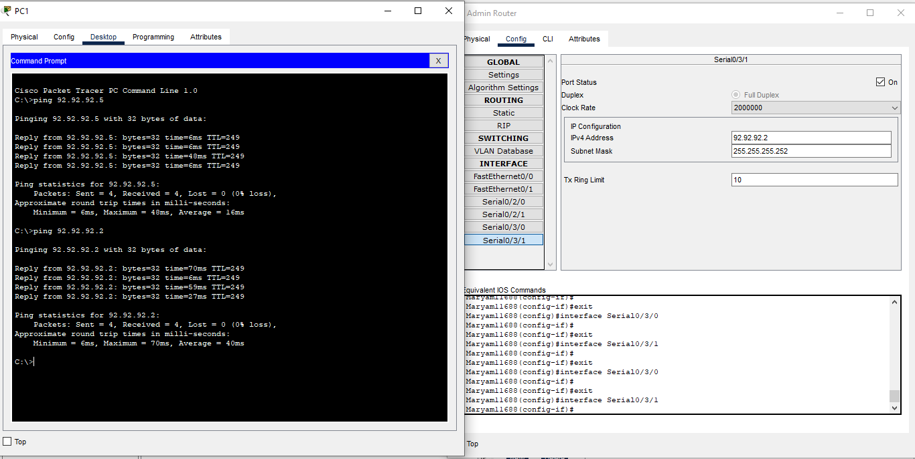

#### **From p1 to p7:**

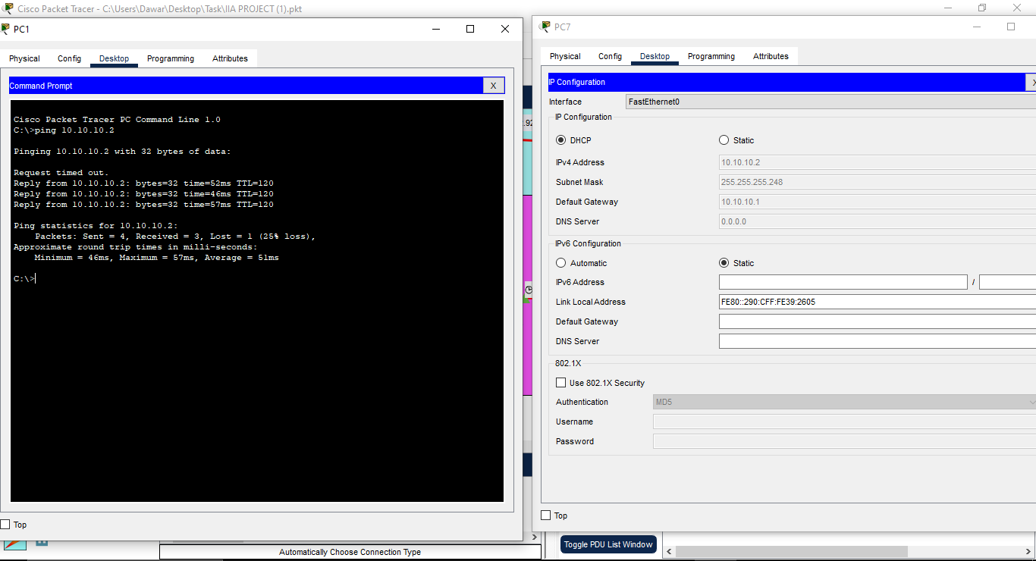

#### **From p6 to security router:**

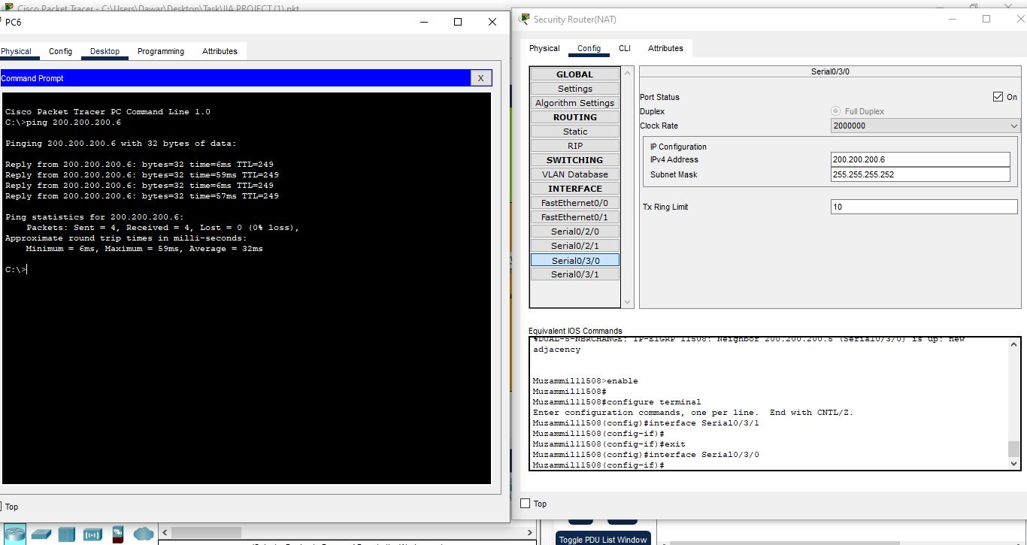

#### **From p7 to doctor router:**

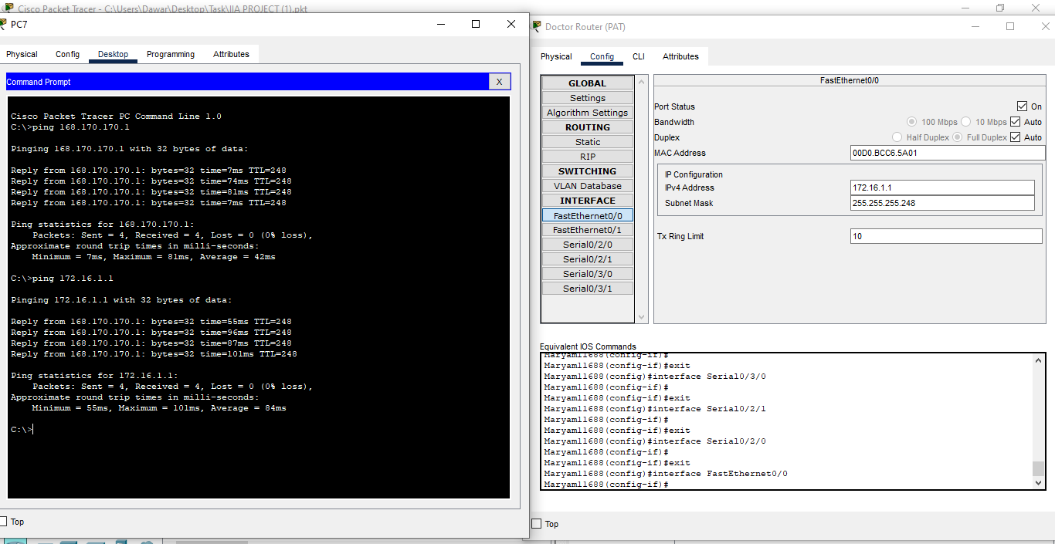

### 

### **PCs Screenshot:**

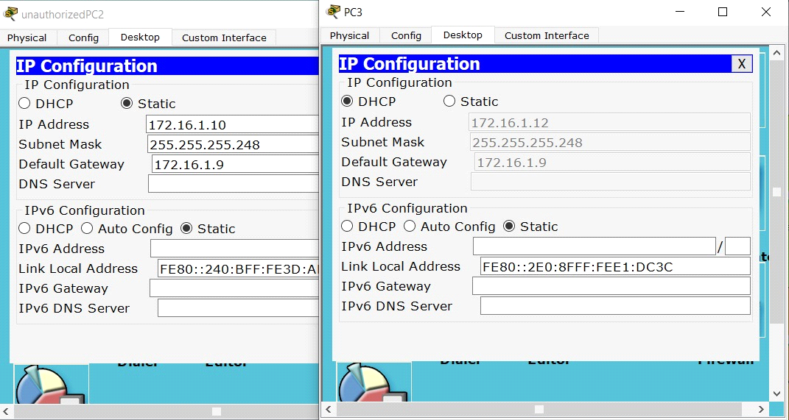

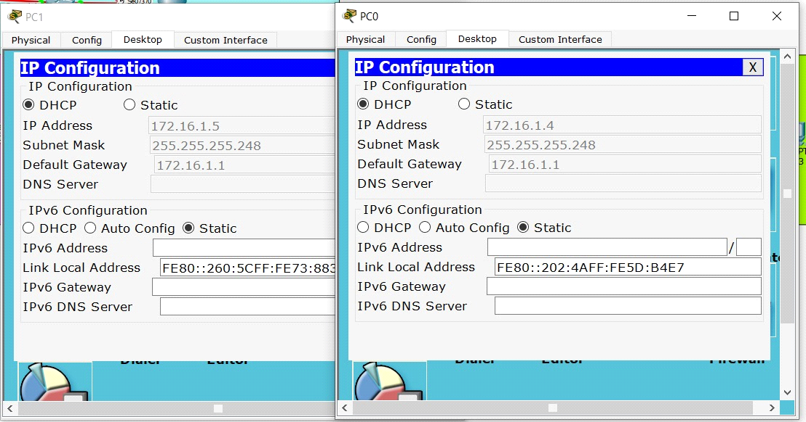

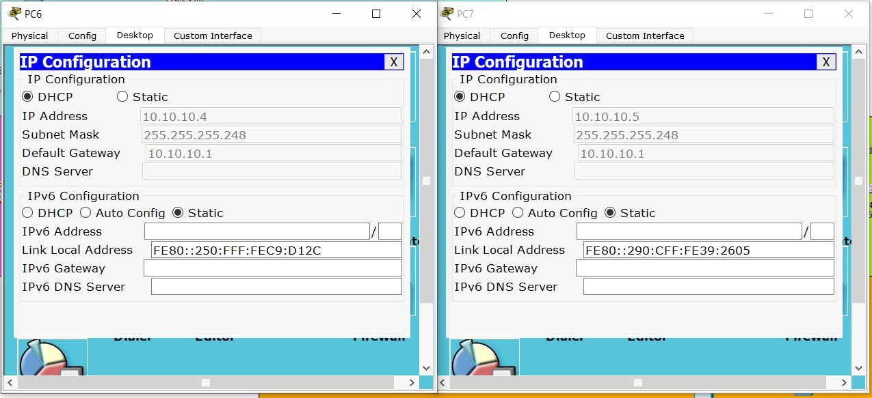

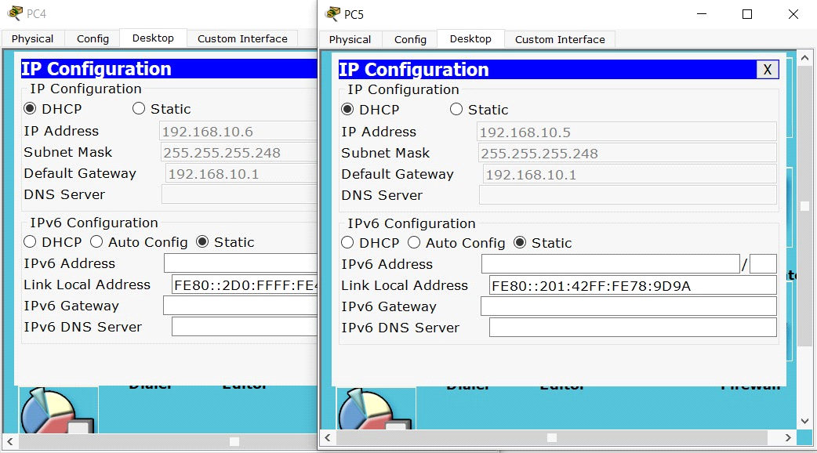

## 

## **Conclusion:**

The Hospital Management System (HMS) project in Cisco Packet Tracer showcases the comprehensive deployment of advanced networking technologies tailored to meet the intricate needs of a hospital environment. Through this project, we successfully designed and implemented a robust network infrastructure that ensures efficient communication, secure data handling, and optimal resource management. Key components such as routers, switches, PCs, and servers were meticulously configured to support the hospital's operational and administrative functions. The integration of public and private IP addressing schemes facilitated seamless internal and external communications, while NAT and PAT enabled efficient IP address utilization and secure internet connectivity. The utilization of Variable Length Subnet Masking (VLSM) allowed for precise IP address allocation, accommodating the varying size requirements of different hospital departments and optimizing the use of available IP space. The hierarchical network design enhanced scalability and manageability, with core, distribution, and access layers ensuring a structured and organized network layout.

Security was a paramount focus, with access control lists (ACLs) implemented to protect sensitive patient data and ensure compliance with healthcare regulations. Overall, the HMS project in Cisco Packet Tracer demonstrates a well-rounded approach to network design and implementation, emphasizing the importance of security, efficiency, and scalability in a healthcare setting. This simulation serves as a valuable model for deploying a modern hospital network, capable of meeting the dynamic and critical demands of today's healthcare industry. By leveraging advanced networking principles and best practices, the project highlights the potential for technology to significantly enhance the functionality and security of hospital operations.

